Rolling Updates and Rollbacks:
Before we look at how to upgrade an application, it's important to understand how rollouts and versioning work in a Kubernetes Deployment.
When you create a Deployment for the first time, Kubernetes automatically triggers a rollout. This initial rollout creates a new ReplicaSet, and the Deployment records it as its first revision (Revision 1).
Later, when you update the application—for example, by changing the container image to a newer version—Kubernetes triggers another rollout. During this process, a new ReplicaSet is created, and the Deployment records the update as a new revision (Revision 2). This revision history allows you to track changes over time and, if necessary, roll back to a previous version of the application. This helps us keep track of the changes made to our deployment, and enables us to roll back to a previous version of deployment if necessary.
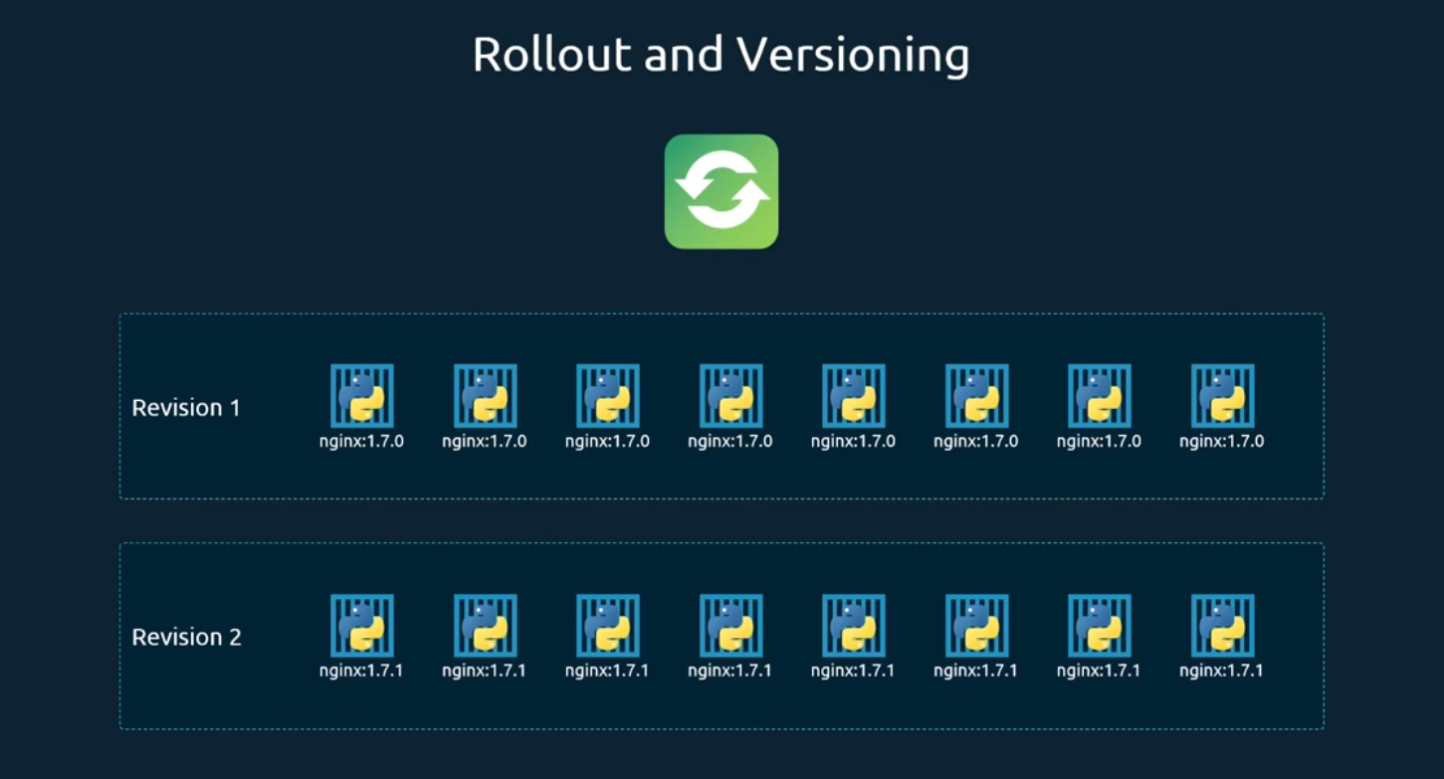
You can see the status of your rollout by running the command kube control rollout status, followed by the name of the deployment.
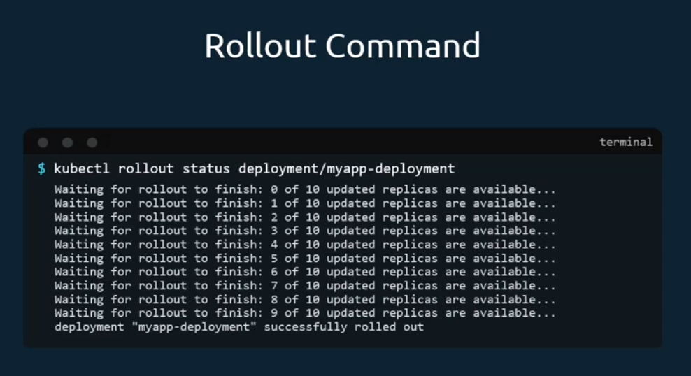
To see the revisions and history of rollout, run the Kube control rollout history command followed by the deployment name, and this will show you the revisions and history of our deployment.
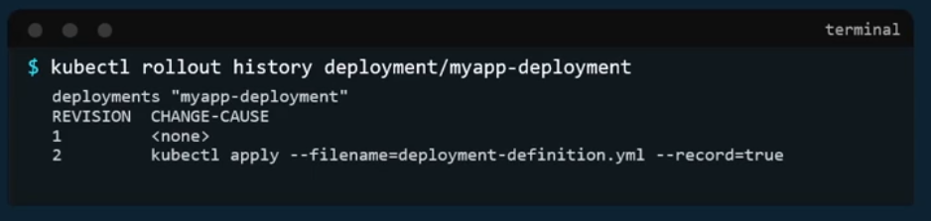
There are two types of deployment strategies. Say for example you have five replicas of your web application instance deployed. One way to upgrade these to a newer version is to destroy all of these, and then create newer versions of application instances, meaning first destroy the five running instances and then deploy five new instances of the new application version.
The problem with this, as you can imagine, is that during the period after the older versions are down and before any newer version is up, the application is down and inaccessible to users. This strategy is known as the recreate strategy, and thankfully this is not the default deployment strategy.
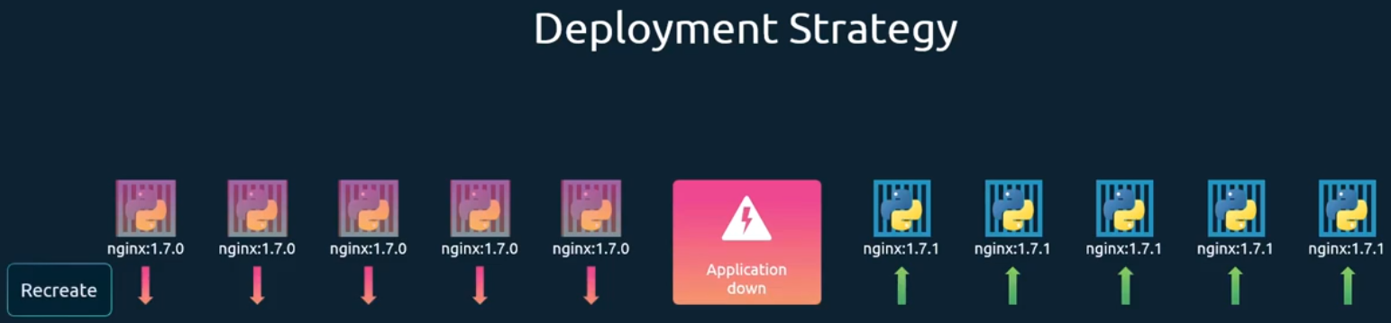
The second strategy is where we do not destroy all of them at once. Instead, we take down the older version and bring up a newer version one by one. This way the application never goes down and the upgrade is seamless. Remember, if you do not specify a strategy while creating the deployment, it will assume it to be rolling.
Update. In other words, rolling update is the default deployment strategy.
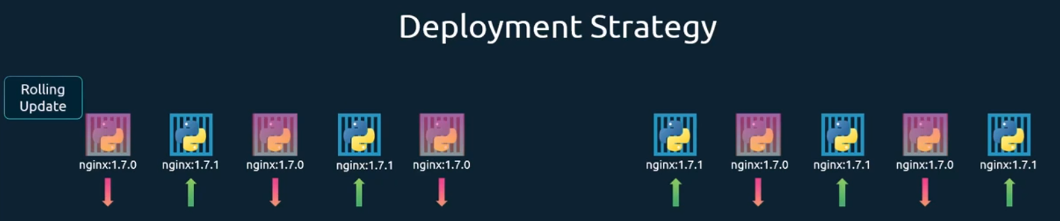
How exactly do you update your deployment?
When I say update, it could be different things, such as updating your application version by updating the version of Docker containers used, updating their labels, or updating the number of replicas, etc.
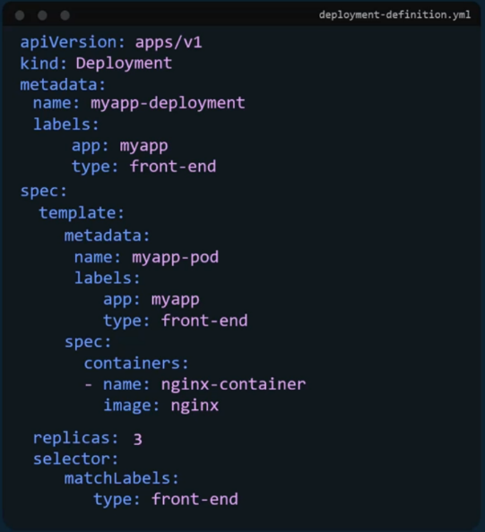
since we already have a deployment definition file, it is easy for us to modify this file once we make the necessary changes. We run the kube control apply command to apply the changes. A new rollout is triggered and a new revision of the deployment is created. But there is another way to do the same thing. You could use the kube control set image command to update the image of your application, but remember, doing it this way will result in the deployment definition file having a different configuration, so you must be careful when using the same definition file to make changes in the future.
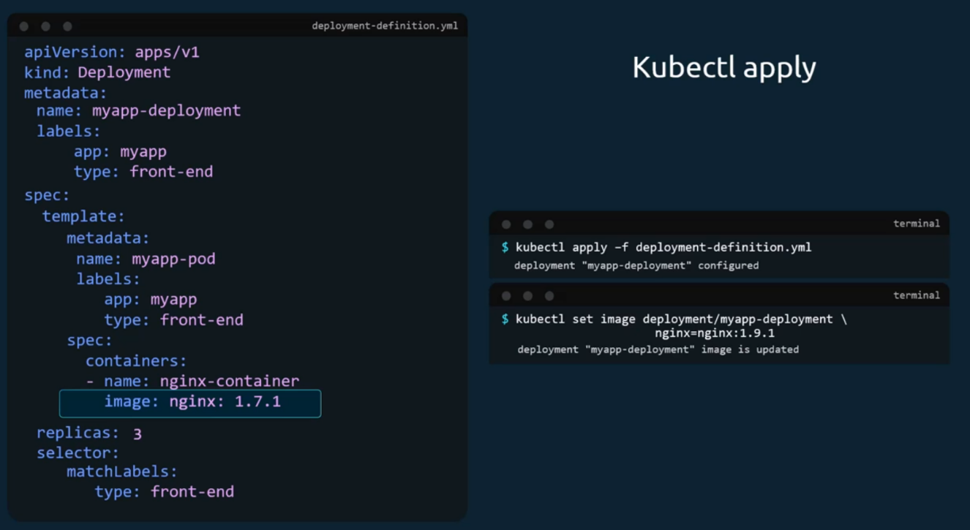
The difference between the recreate and rolling update strategies can also be seen when you view the deployments in detail. From the kube control describe deployment command to see the details information regarding the deployments. You will notice when the recreate strategy was used. The events indicate that the old replica set was scaled down to zero first, and then the new replica set scaled up to five.
However, when the rolling update strategy was used, the old replica set was scaled down one at a time, simultaneously scaling up the new replica set one at a time.
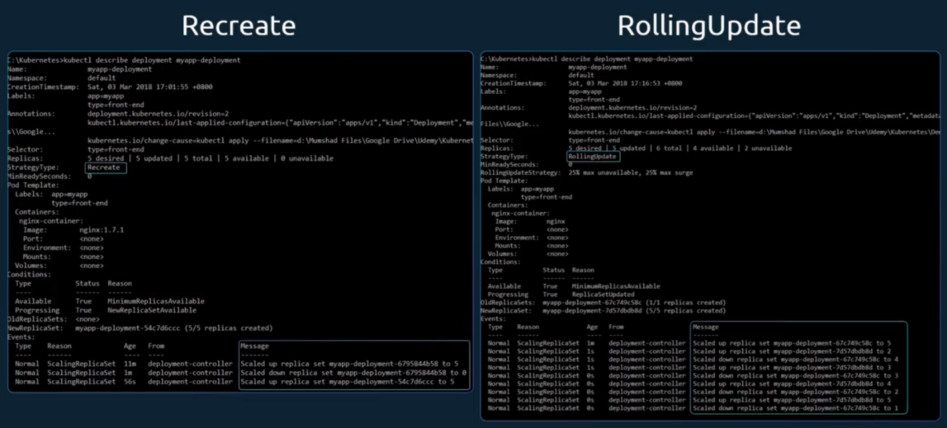
Let's look at how a deployment performs an upgrade under the hood when a new deployment is created, say, to deploy five replicas, it first creates a replica set automatically, which in turn creates the number of pods required to meet the number of replicas. When you upgrade your application, as we saw in the previous slide, the Kubernetes deployment object creates a new replica set. Under the hood and starts deploying the containers there, at the same time taking down the pods in the old replica set following a rolling update strategy. This can be seen when you try to list the replica sets using the Kube control get replica sets command. Here we see the old replica set with zero pods and the new replica set with five pods.
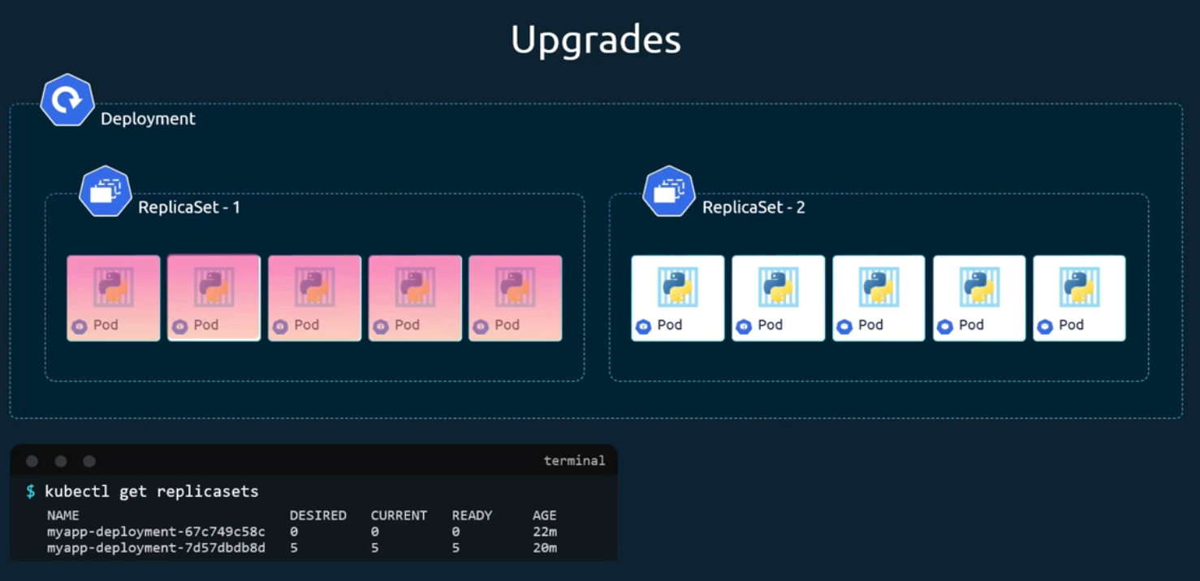
Say for instance, once you upgrade your application, you realize something isn't very right. Something's wrong with the new version of build you use to upgrade. So, you would like to roll back your update. Kubernetes deployments allow you to roll back to a previous revision to undo a change. Run the kube control rollout undo command followed by the name of the deployment. The deployment will then destroy the pods in the new replica set and bring the older ones up in the old replica set, and your application is back to its older format.
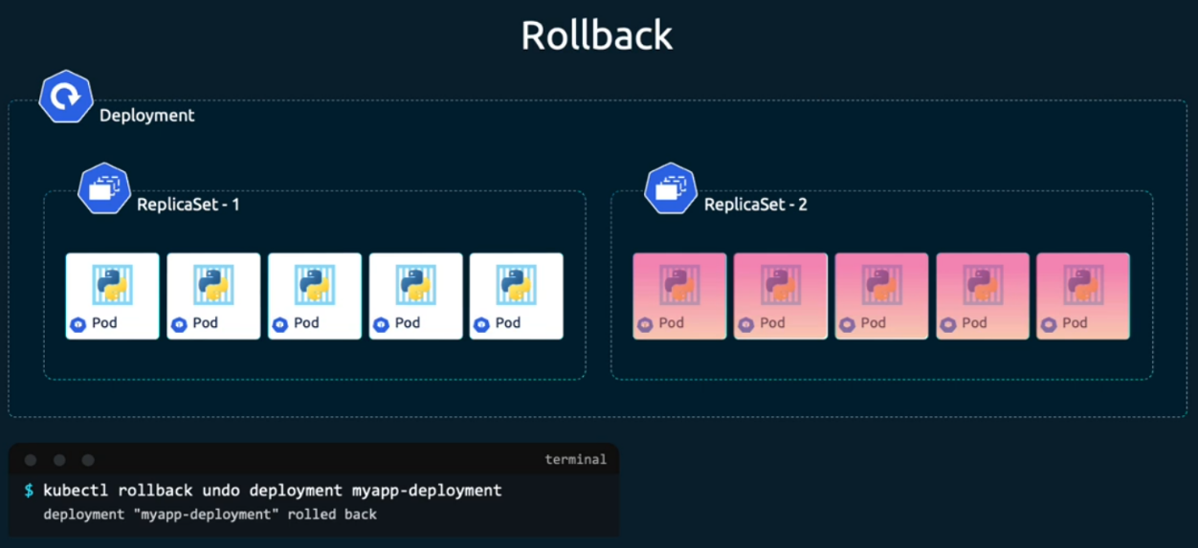
When you compare the output of the cube control, get replica sets command before and after the rollback. You will be able to notice this difference before the rollback. The first replica set had zero pods and new replica set had five pods, and this is reversed after the rollback is finished.
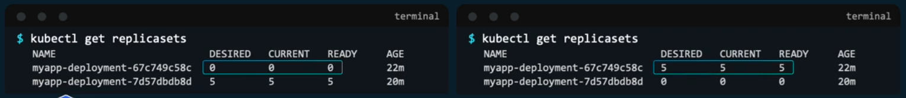
To summarize the commands:
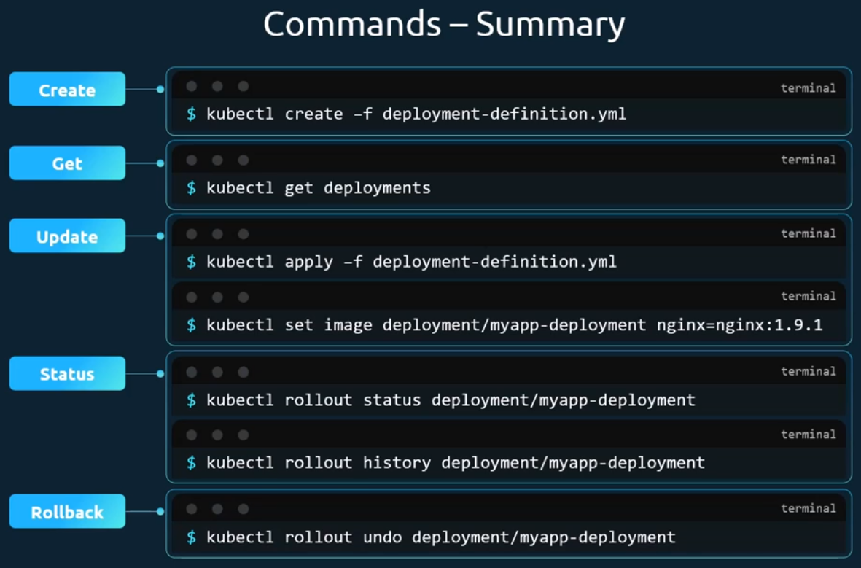

Commands and Arguments in Docker:
We will look at commands, arguments and entry points in Docker. Let's start with a simple scenario. you were to run a Docker container from an ubuntu image. When you run the docker run ubuntu command, it runs an instance of ubuntu image and exits immediately.
If you were to list the running containers, you wouldn't see the container running. If you list all containers, including those that are stopped, you will see that the new container you ran is in an exited state.
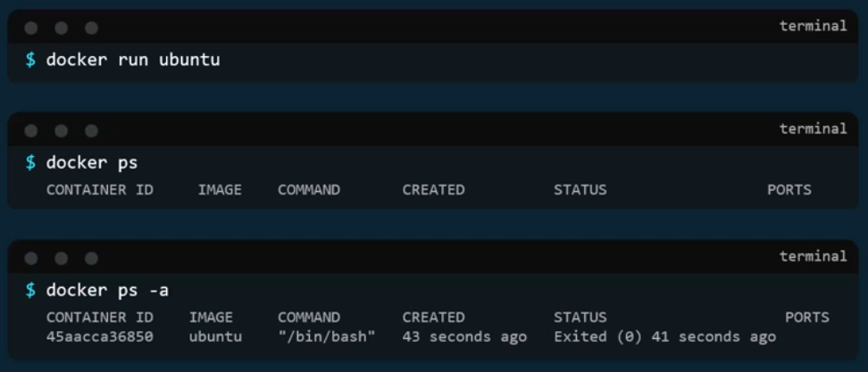
Now why is that? Unlike virtual machines, containers are not meant to host an operating system. Containers are meant to run a specific task or process, such as to host an instance of a web server or application server, or a database, or simply to carry out some kind of computation or analysis.
Once the task is complete, the container exits. A container only lives as long as the process inside it is alive. If the web service inside the container is stopped or crashes, the container exits.
Who defines what process is run within the container?
If you look at the Docker file for popular Docker images like nginx, you will see an instruction called cmd, which stands for command that defines the program that will be run within the container when it starts. For the nginx image, it is the nginx command. For the MySQL image it is the MySQL command.
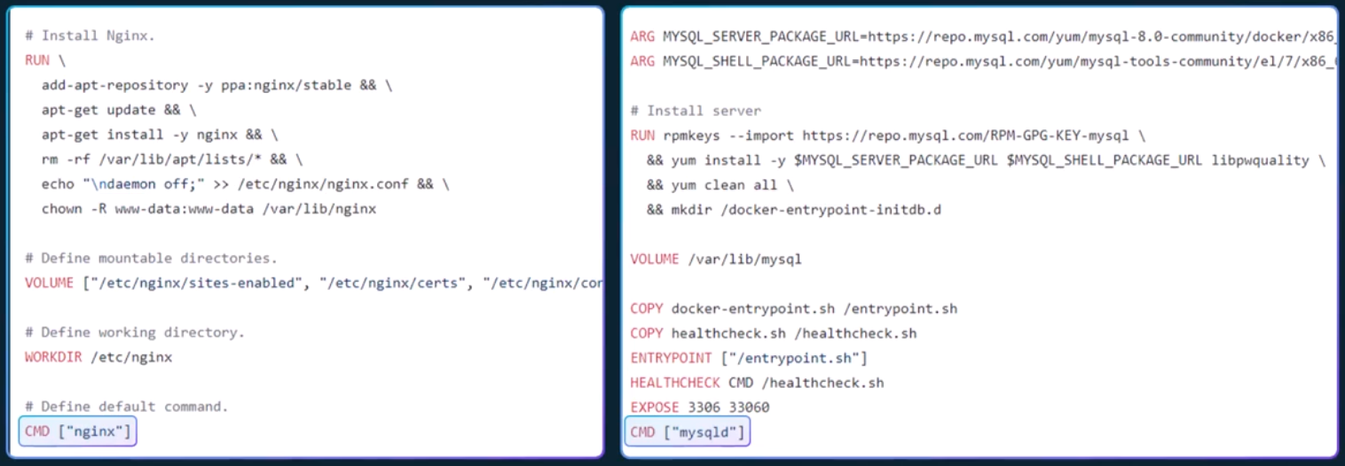
What we tried to do earlier was to run a container with a plain ubuntu operating system. Let us look at the docker file for this image. You will see that it uses bash as the default command.
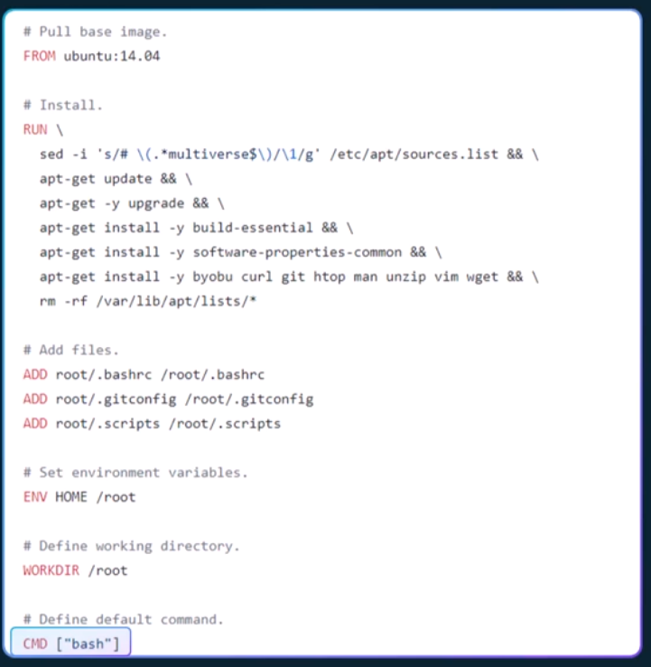
Now bash is not really a process like a web server or database server. It is a shell that listens for inputs from a terminal. If it cannot find a terminal, it exits. When we run the ubuntu container earlier, Docker created a container from the ubuntu image and launched the bash program. By default, Docker does not attach a terminal to a container when it is run and the bash program does not find the terminal and so it exits.
Since the process that was started when the container was created finished the container exits as well. So how do you specify a different command to start the container? One option is to append a command to the docker run command. And that way it overrides the default command specified within the image.
I run the docker run ubuntu command with the sleep five command as the added option.
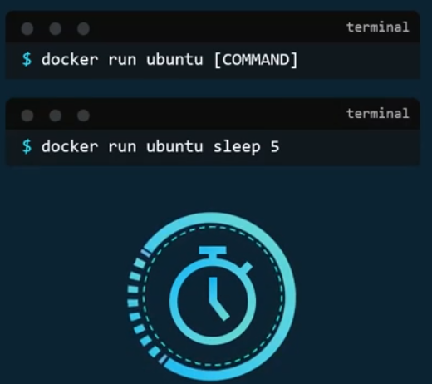
This way when the container starts, it runs the sleep program, waits for five seconds and then exits. But how do you make that change permanent? Say you want the image to always run the sleep command when it starts. You would then create your own image from the base ubuntu image and specify a new command. There are different ways of specifying the command, either the command simply as is in a shell form, or in a JSON array format like this. But remember, when you specify in a JSON array format, the first element in the array should be the executable. In this case, the sleep program does not specify the command and parameters together like this. The command and its parameters should be separate elements in the list.
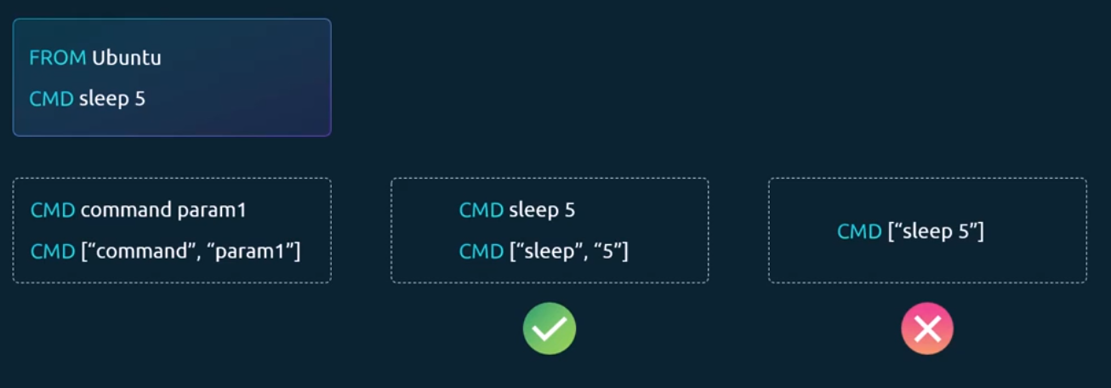
I now build my new image using the docker build command and name it as Ubuntu Sleeper.
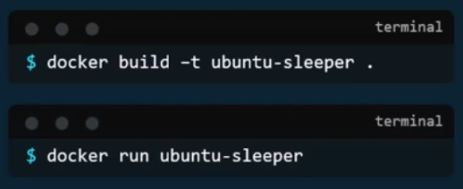
I could now simply run the Docker ubuntu sleeper command and get the same results. It always sleeps for five seconds and exits. But what if I wish to change the number of seconds it sleeps? Currently it is hard coded to five seconds. As we learned before, one option is to run the docker run command with the new command appended to it.
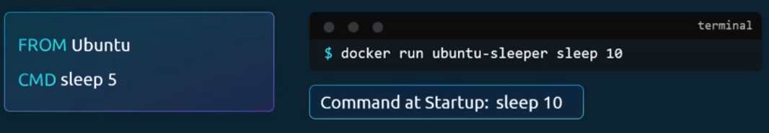
In this case, sleep ten and so the command that will be run at startup will be sleep ten.
But it doesn't look very good. The name of the image, ubuntu Sleeper in itself implies that the container will sleep. So, we shouldn't have to specify the sleep command again. Instead, we would like it to be something like this. Docker run ubuntu sleeper ten.
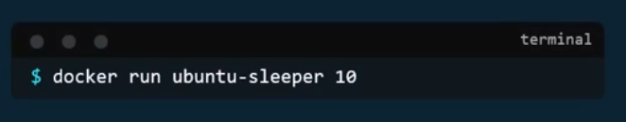
We only want to pass in the number of seconds the container should sleep, and sleep command should be invoked automatically and that is where the entry point instruction comes into play. Entry point defines the executable command.
CMD provides default args as in. You can specify the program that will be run when the container starts, and whatever you specify on the command line. In this case, ten will get appended to the entry point.
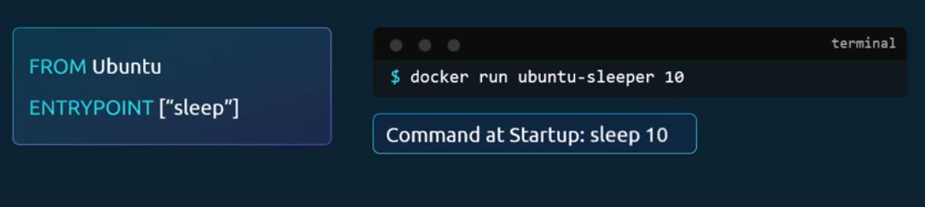
So, the command that will be run when the container starts are sleep ten.
So that's the difference between the two. In case of the CMD instruction the command line parameters passed will get replaced entirely, whereas in case of entry point the command line parameters will get appended. Now in the second case, what if I run the ubuntu sleeper image command without appending the number of seconds? Then the command at startup will be just sleep and you get the error that the operand is missing.
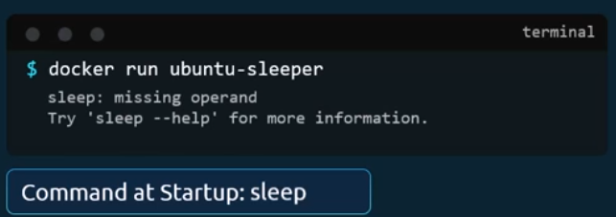
So how do you configure a default value for the command if one was not specified in the command line. That's where you would use both entry-point as well as the command instruction. In this case, the command instruction will be appended to the entry-point instruction. So, at startup the command would be sleep five if you didn't specify any parameters in the command line. If you did then that will override the command instruction and remember for this to happen, you should always specify the entry point and command instructions in a JSON format.
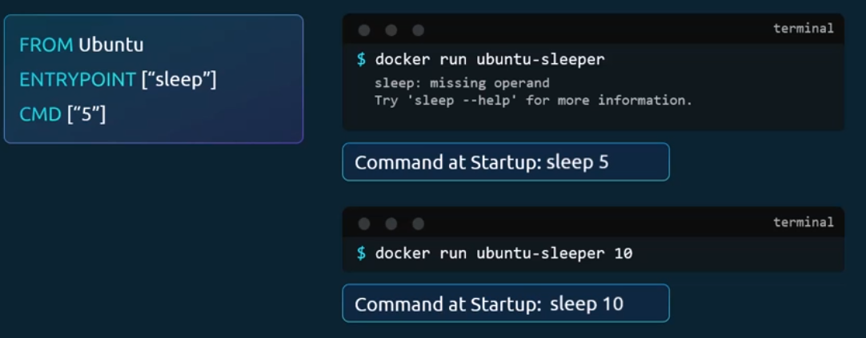
Finally, what if you really want to modify the entry point during runtime, say from sleep to an imaginary sleep 2.0 command? Well, in that case, you can override it by using the entry-point option in the docker run command. The final command at startup would then be sleep 2.0 ten.
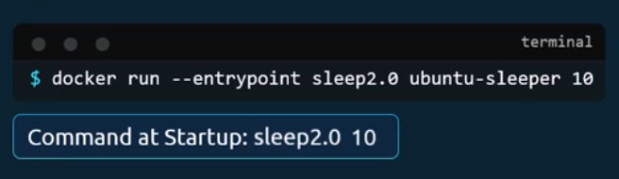

Commands and Arguments in Kubernetes:
In the previous lecture, we created a simple Docker image that sleeps for a given number of seconds. We named it Ubuntu Sleeper and we ran it using the docker command Docker run ubuntu sleeper. By default, it sleeps for five seconds, but you can override it by passing a command line argument.
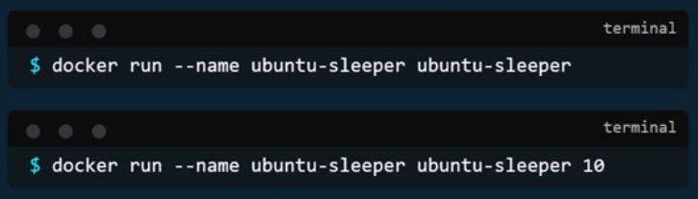
We will now create a pod using this image. We start with a blank pod definition template, input the name of the pod and specify the image name. When this pod is created, it creates a container from the specified image and the container sleeps for five seconds before exiting. Now, if you need the container to sleep for 10s as in the second command, how do you specify the additional argument in the pod definition file? Anything that is appended to the docker run command will go into the args property of the pod definition file in the form of an array like this. Let us try to relate that to the docker file we created earlier. The docker file has an entry point as well as a cmd instructions Specified, the entry point is the command that is run at startup, and the cmd is the default parameter passed to the command with the args option in the Pod definition file. We override the cmd instruction in the docker file. But what if you need to override the entry point, say from sleep to an imaginary sleep 2.0 command? In the Docker world, we would run the docker run command with the entry point option set to the new command. The corresponding entry in the pod definition file would be using a command field. The command field corresponds to entry point instruction in the docker file.
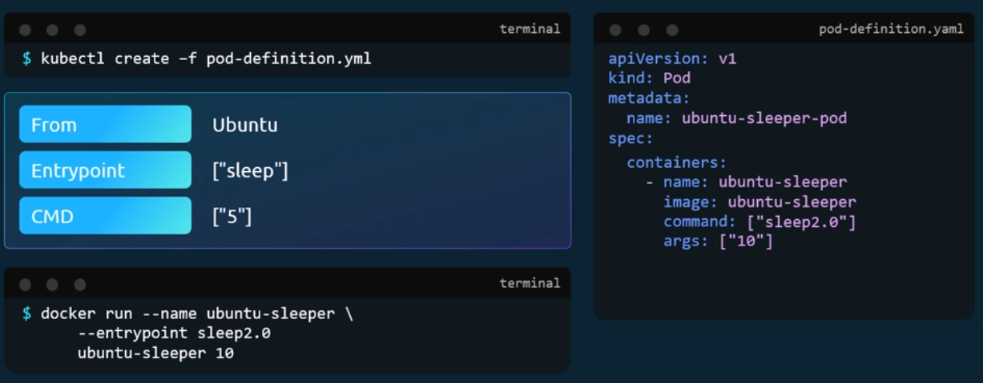
So, to summarize, there are two fields that correspond to two instructions in the docker file. The command field overrides the entry point instruction, and the args field overrides the command instruction in the docker file. Remember, it is not the command field that overrides the cmd instruction in the docker file.
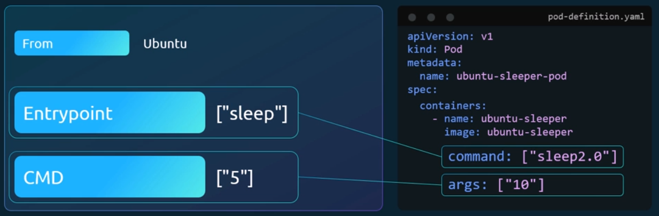

Configure Environment Variables in Applications:
We will see how to set an environment variable in Kubernetes.
Given a Pod definition file which uses the same image as the docker command, we ran in the last lecture to set an environment variable, use the env property. Env is an array, so every item under the env property starts with a dash indicating an item in the array. Each item has a name and a value property. The name is the name of the environment variable made available with the container, and the value is its value.
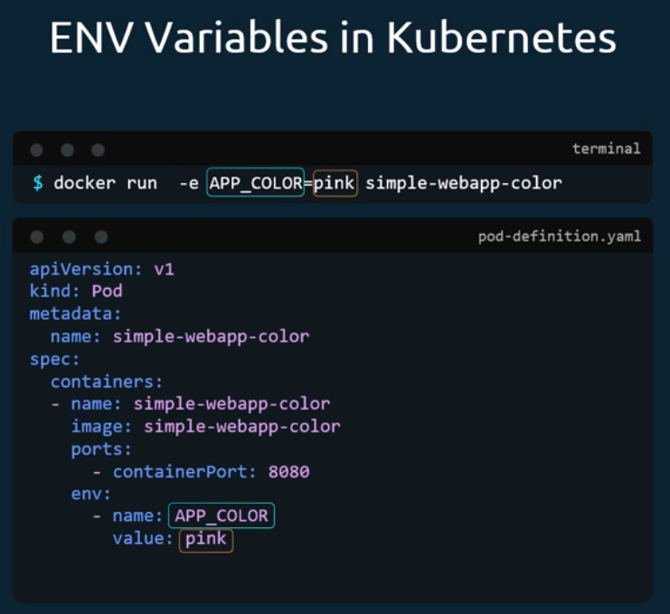
What we just saw was a direct way of specifying the environment variables using a plain key value pair format.
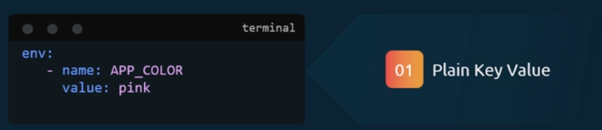
However, there are other ways of setting the environment variables, such as using configmaps and secrets. The difference in this case is that instead of specifying value, we say value from and then a specification of configmap or secret.
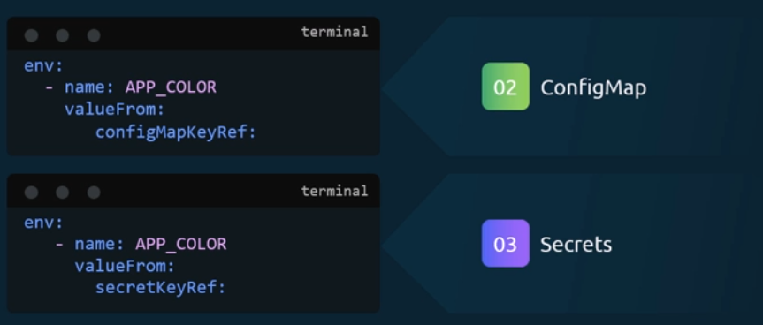

Configuring ConfigMaps in Applications:
In this lecture we will discuss how to work with configuration data in Kubernetes. In the previous lecture we saw how to define environment variables in a Pod definition file. When you have a lot of Pod definition files, it will become difficult to manage the environment data stored within the various files. We can take this information out of the Pod definition file and manage it centrally using configuration maps. Config maps are used to pass configuration data in the form of key value pairs in Kubernetes. When a pod is created, inject the configmap into the pod so the key value pairs are available as environment variables for the application hosted inside the container in the pod. There are two phases involved in configuring Configmaps. First, create the Configmap and second, inject them into the pod.
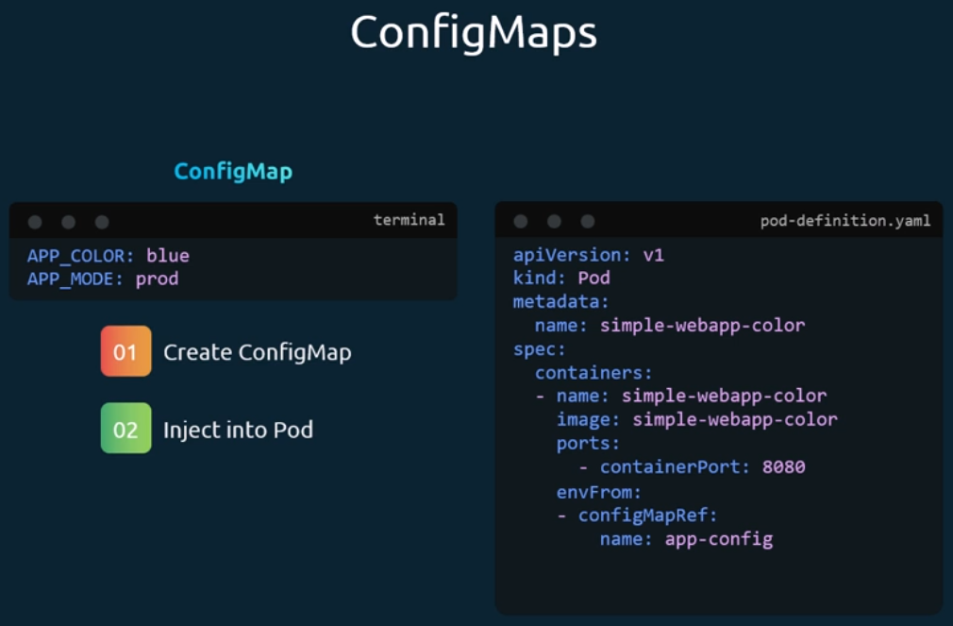
Just like any other Kubernetes object. There are two ways of creating a Configmap. The imperative way without using a config map definition file and the declarative way by using a config map definition file.
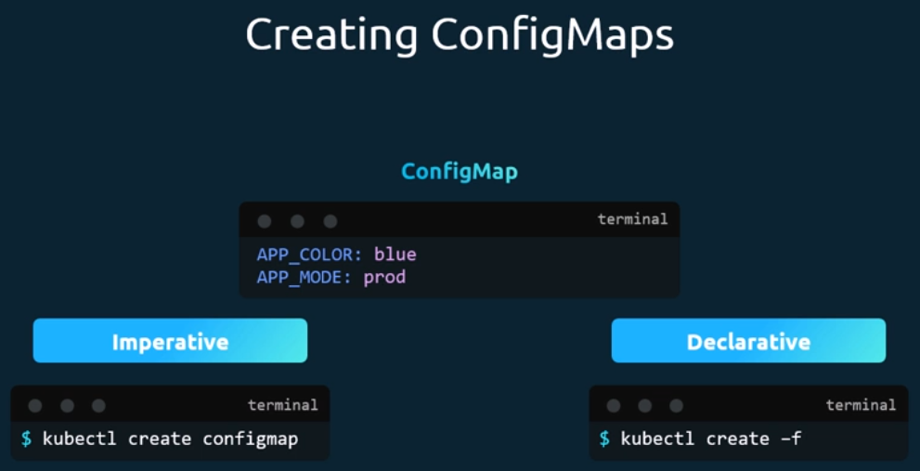
If you do not wish to create a config map definition file, you could simply use the cube control create config map command and specify the required arguments.
Let's take a look at that first. With this method, you can directly specify the key value pairs in the command line to create a config map of the given values. Run the cube control. Create config map command. The command is followed by the config name and the option from literal. The firm literal option is used to specify the key value pairs in the command itself.
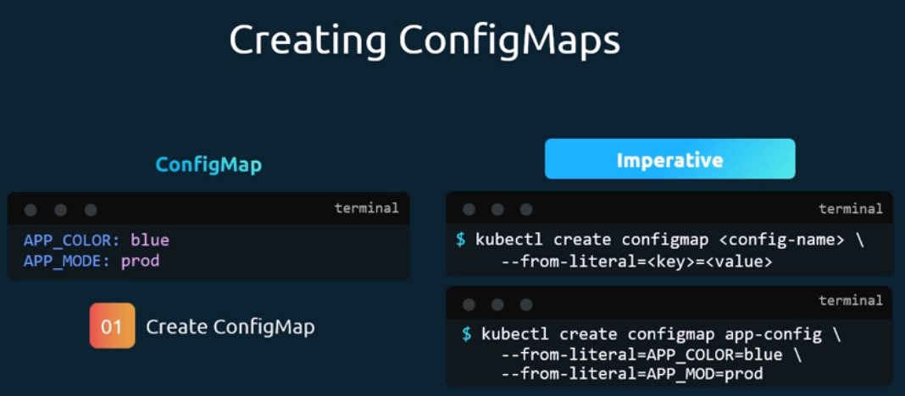
In this example, we are creating a config map by the name appconfig with a key value pair of app color equal’s blue. If you wish to add additional key value pairs, simply specify the from literal options multiple times.
However, this will get complicated when you have too many configuration items.
Another way to input configuration data is through a file. Use the from file option to specify a path to the file that contains the required data. The data from this file is read and stored under the name of the file.
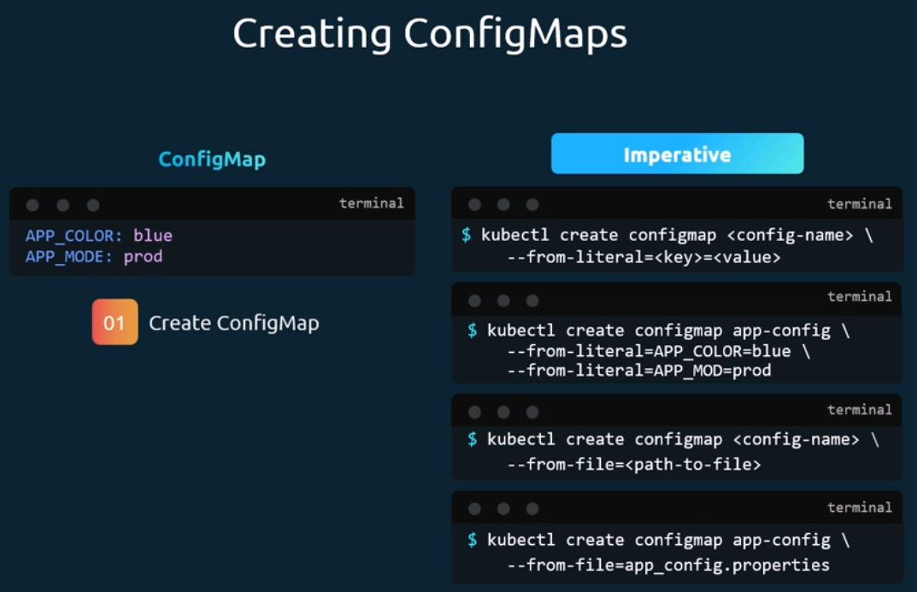
Let us now look at the declarative approach for this. We create a definition file just like how we did for the pod. The file has an API version kind metadata instead of spec. Here we have data. The API version is v1. The kind is configmap. Under metadata we specify a name for the Configmap. We will call it app-config under data and the configuration data in a key value format. Run the cube control, create command and specify the configuration file name.
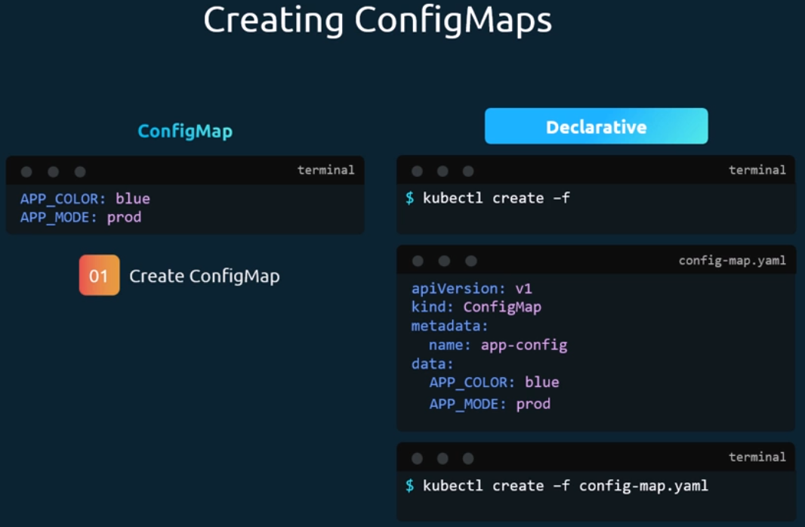
So that creates the app-config Configmap map with the values we specify. You can create as many config maps as you need in the same way for various different purposes.
Here I have one of my applications, another for MySQL and another one for redes. So, it is important to name the config maps appropriately as you will be using these names later while associating it with pods.
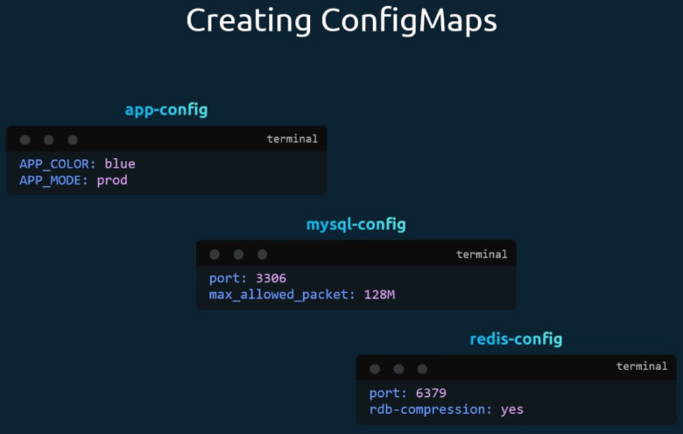
To view config maps, run the kube control get Configmaps command. This lists the newly created config map named Appconfig. The describe configmaps command lists the configuration data as well under the data section.
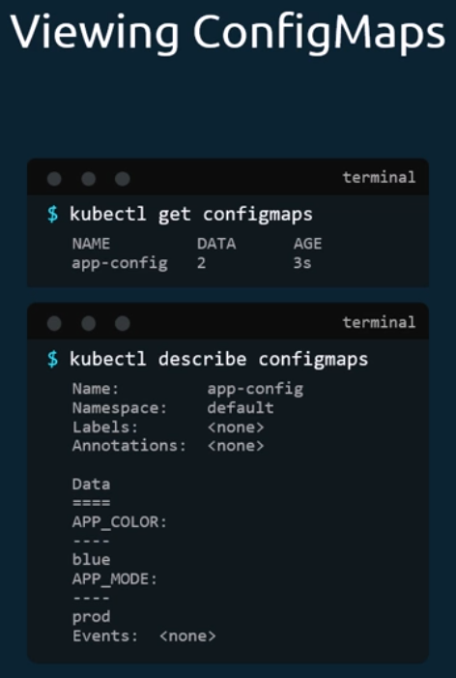
Now that we have the config map created, let us proceed with step two. Configuring it with a pod. Here I have a simple pod definition file that runs my simple web application. To inject an environment variable, add a new property to the container called env from the env from property is a list so we can pass as many environment variables as required. Each item in the list corresponds to a config map item. Specify the name of the config map we created earlier. This is how we inject a specific config map from the ones we created before creating the pod definition file. Now creates a web application with a blue background. What we just saw was using config maps to inject environment variables.

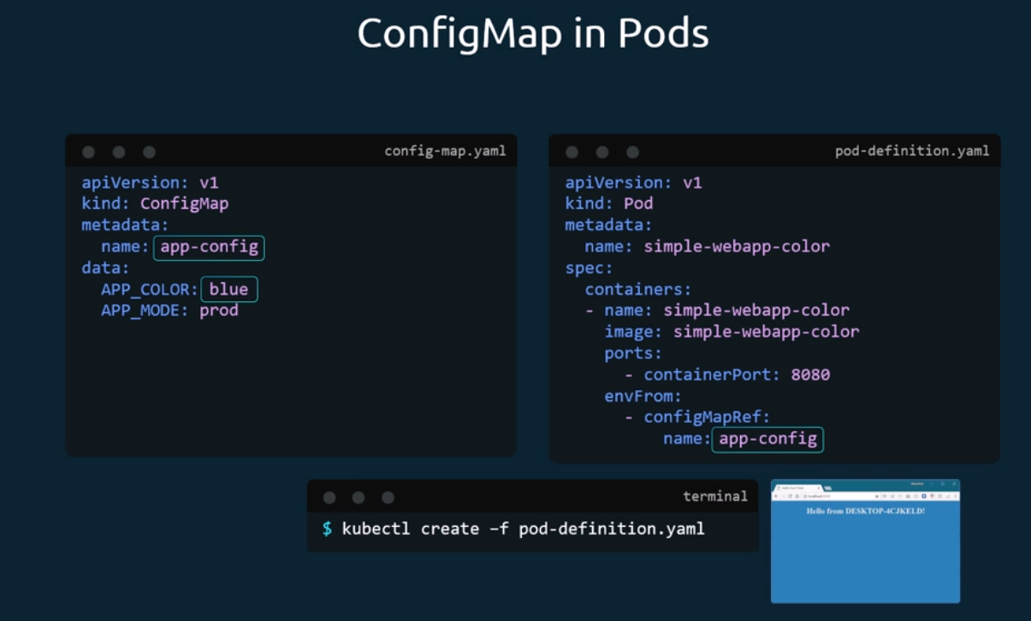
There are other ways to inject configuration data into pods. You can inject it as a single environment variable, or you can inject the whole data as files in a volume.
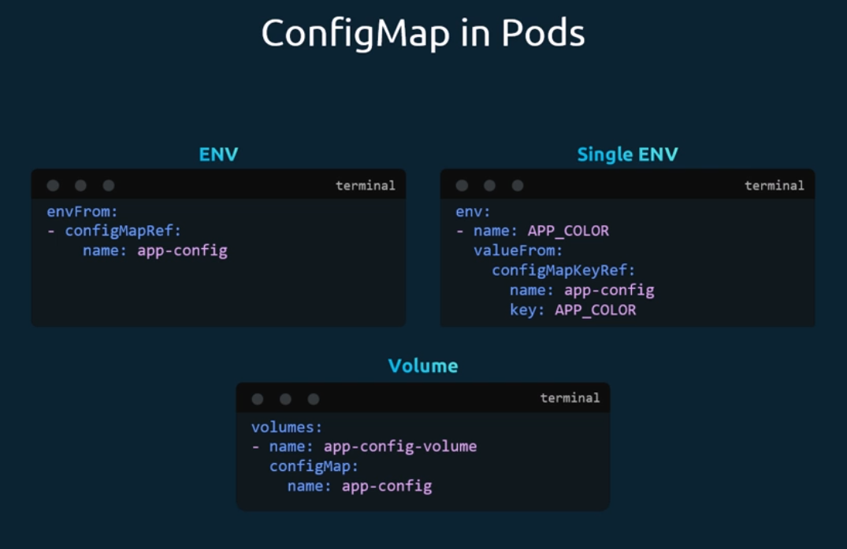

Secrets:
Here we have a simple Python web application that connects to a MySQL database. On success, the application displays a successful message. If you look closely into the code, you will see the host name, username and password hardcoded. This is of course not a good idea. As we learned in the previous lecture, one option would be to move these values into a config map. The config map stores the configuration data in plain text format. So, while it would be okay to move the host name and username into a config map, it is definitely not the right place to store a password.
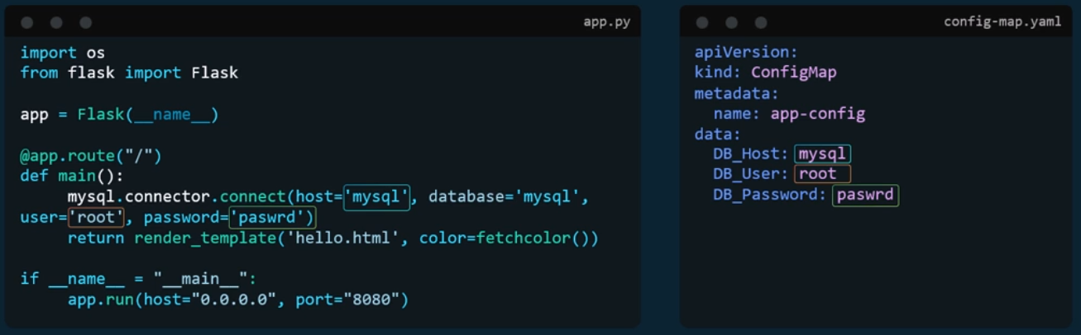
This is where secrets come in. Secrets are used to store sensitive information like passwords or keys. They are similar to config maps, except that they are stored in an encoded or hashed format. As with config maps, there are two steps involved in working with secrets. First, create the secret and second, inject it into pod.
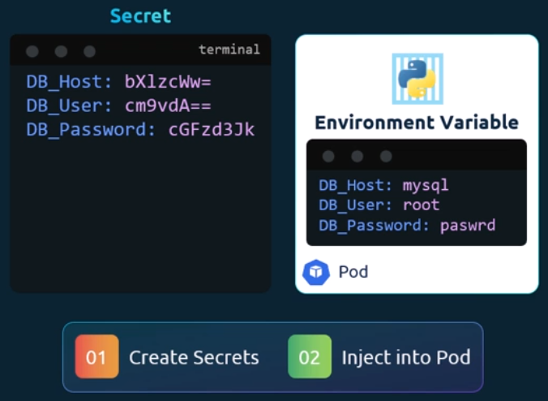
There are two ways of creating a secret. The imperative way without using a secret definition file and the declarative way, By using a secret definition file.
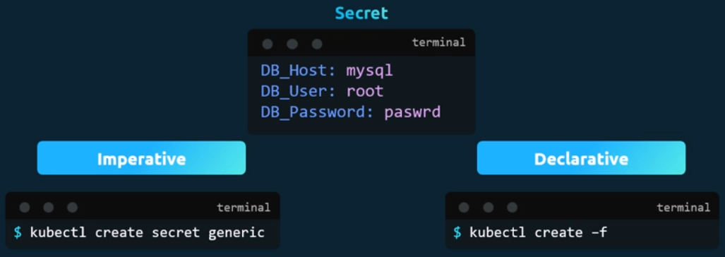
With the imperative method, you can directly specify the key value pairs in the command line itself to create a secret of the given values. Run the kube control Create secret generic command. The command is followed by the secret name and the option from literal. The from literal option is used to specify the key value pairs in the command itself. In this example, we are creating a secret by the name app secret with a key value pair db underscore host equals MySQL. If you wish to add additional key value pairs, simply specify the from literal options multiple times. However, this could get complicated when you have too many secrets to pass in. Another way to input the secret data is through a file. Use the from file option to specify a path to the file that contains the required data. The data from this file is read and stored under the name of the file.
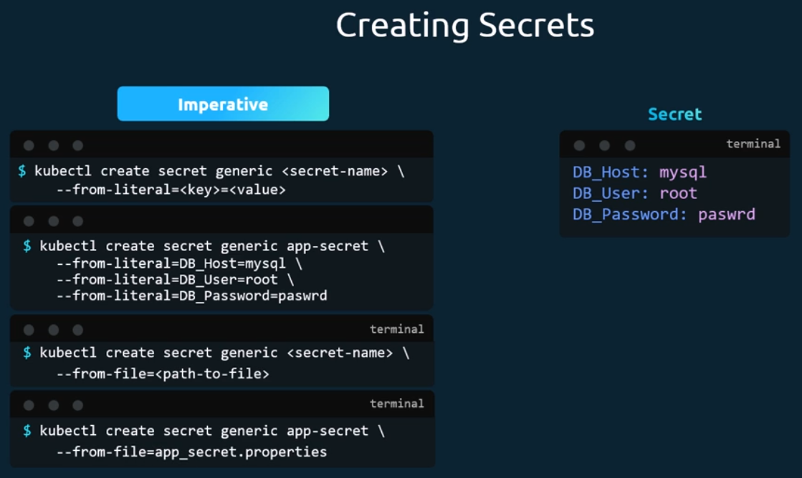
Let us now look at the declarative approach. For this we create a definition file just like how we did for the config map. The file has API version kind metadata and data. The API version is v1. Kind is secret. Under metadata specify the name of the secret. We will call it app secret under data. Add the secret data in a key value format. However, one thing we discussed about secrets was that they are used to store sensitive data and are stored in an encoded format. Here we have specified the data in plain text, which is not very safe.
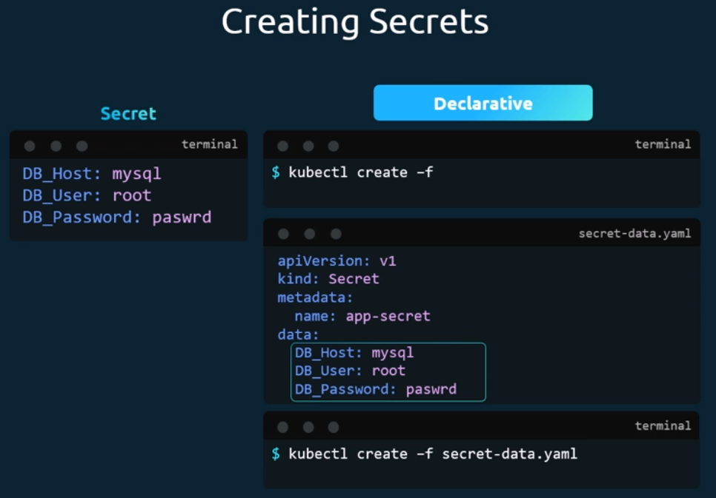
So, while creating a secret with a declarative approach, you must specify the secret values in a hashed format. So, you must specify the data in an encoded form like this.
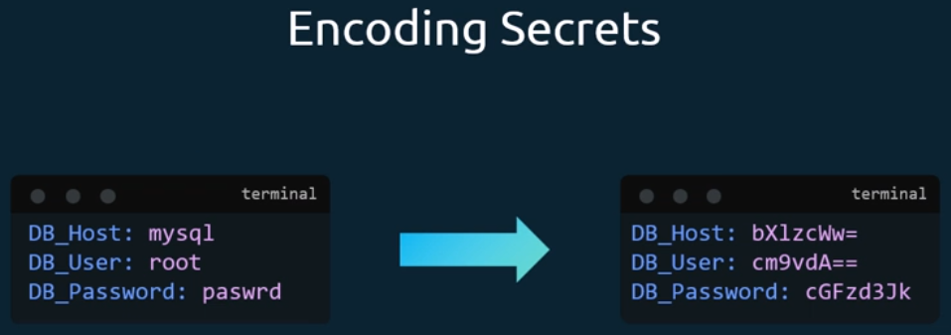
But how do you convert the data from plain text to an encoded format on a Linux host? Run the command echo n followed by the text you're trying to convert, which is MySQL in this case, and pipe that to the base64 utility.
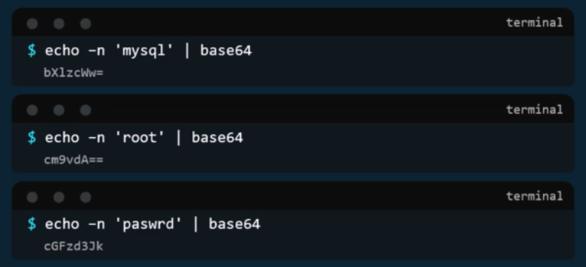
To view secrets. Run the kube control get secrets command. This lists the newly created secret along with another secret previously created by Kubernetes for its internal purposes.

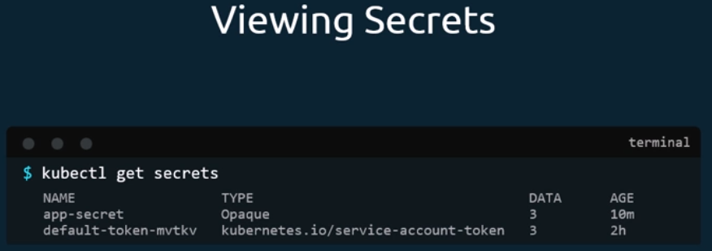
To view more information on the newly created secret, run the Kube control describe secret command. This shows the attributes in the secret, but hides the value themselves.
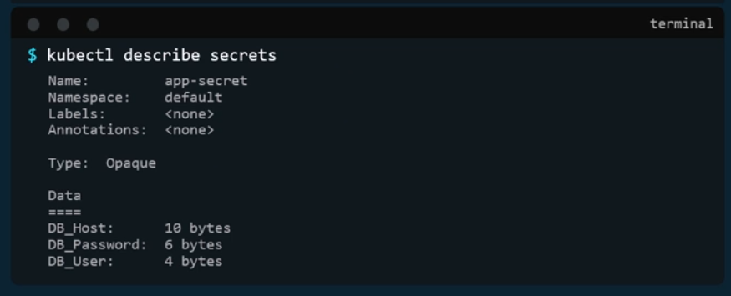
To view the values as well. Run the Kube control. Get secret command with the output displayed in YAML format using the O option. You can now see the hashed values as well.
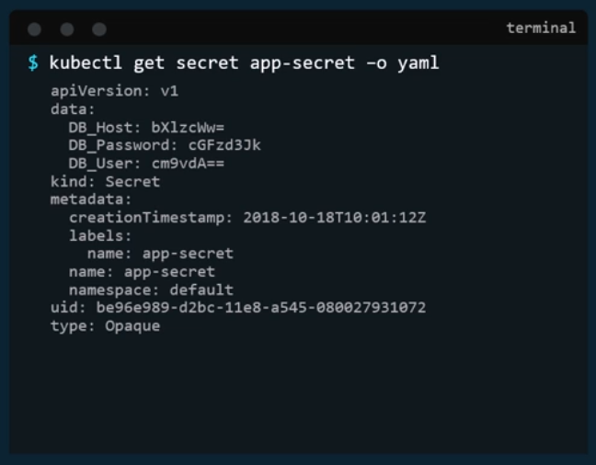
Now how do you decode these hashed values? Use the same base64 command used earlier to encode it, but this time add a decode option to it.
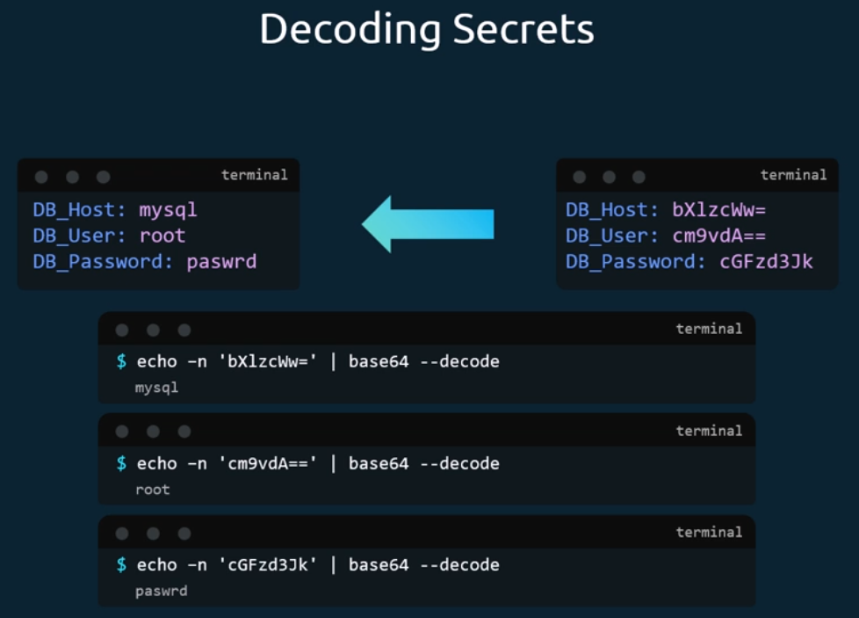
Now that we have secret created, let us proceed with step two. Configuring it with a pod.
Here I have a simple pod definition file that runs my application to inject an environment variable. Add a new property to the container called env from, the env from property is a list so we can pass as many environment variables as required. Each item in the list corresponds to a secret item. Specify the name of the secret we created earlier. Creating the pod definition file now makes the data in the secret available as environment variables for the application.
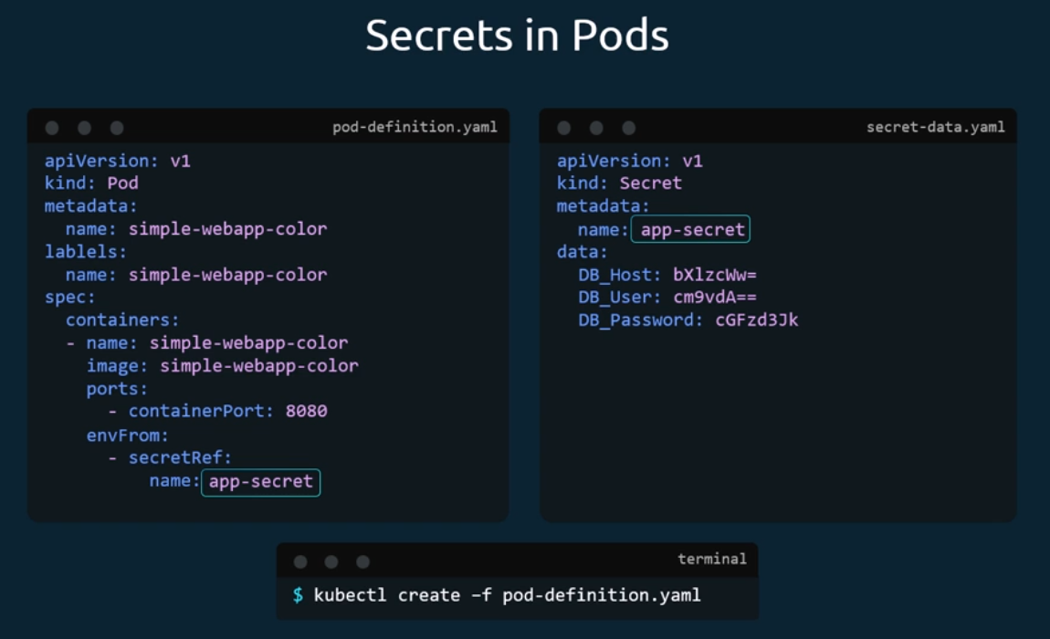
What we just saw was injecting secrets as environment variables into the pods. There are other ways to inject secrets into pods. You can inject as single environment variables or inject the whole secret as files in a volume.
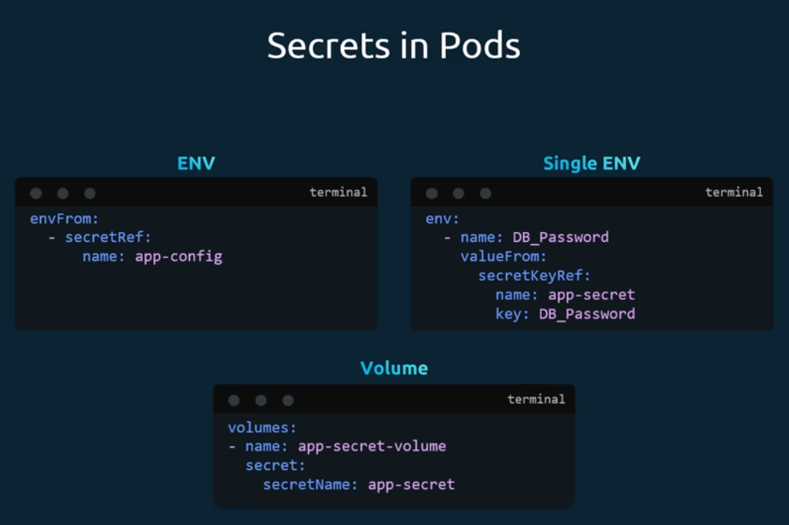
If you were to mount the secret as a volume in the pod, each attribute in the secret is created as a file with the value of the secret as its content. In this case, since we have three attributes in our secret, three files are created, and if we look at the contents of the db_password file, we see the password in it.
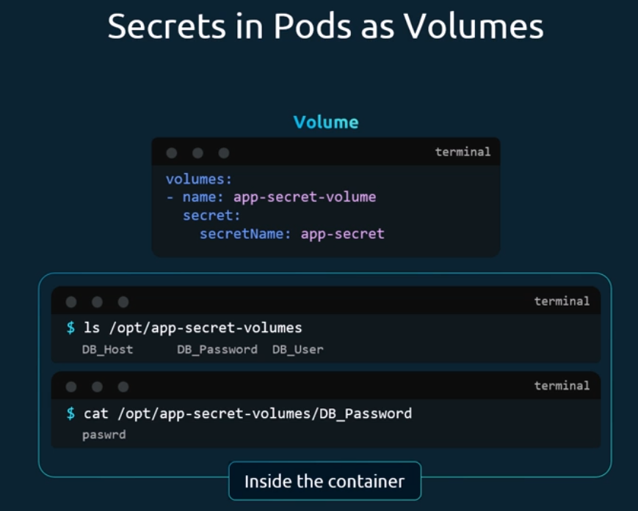

Demo Encrypting Secret Data at Rest:
if create new secret key:
kubectl create secret generic my-secret --from-literal=key1=supersecret

and get secret kye:
kubectl get secret
ETCDCTL_API=3 etcdctl --cacert=/etc/kubernetes/pki/etcd/ca.crt --cert=/etc/kubernetes/pki/etcd/server.crt --key=/etc/kubernetes/pki/etcd/server.key get /registry/secrets/default/my-secret | hexdump -C
can see the key and value
Make the new encrypted file:

vi enc.yaml

apiVersion: apiserver.config.k8s.io/v1
kind: EncryptionConfiguration
resources:
- resources:
- secrets
providers:
- aescbc:
keys:
- name: key1
secret: inlinux: head -c 32 /dev/urandom | base64
- identity: {} # REMOVE THIS LINE

mkdir /etc/kubernetes/enc/
mv enc.yaml /etc/kubernetes/enc/

vi /etc/kubernetes/manifests/kube-apiserver.yaml

apiVersion: v1
kind: Pod
metadata:
annotations:
kubeadm.kubernetes.io/kube-apiserver.advertise-address.endpoint: 10.20.30.40:443
creationTimestamp: null
labels:
app.kubernetes.io/component: kube-apiserver
tier: control-plane
name: kube-apiserver
namespace: kube-system
spec:
containers:
- command:
- kube-apiserver
...
- --encryption-provider-config=/etc/kubernetes/enc/enc.yaml # add this line
volumeMounts:
...
- name: enc # add this line
mountPath: /etc/kubernetes/enc # add this line
readOnly: true # add this line
...
volumes:
...
- name: enc # add this line
hostPath: # add this line
path: /etc/kubernetes/enc # add this line
type: DirectoryOrCreate # add this line
...
now if create a new secret kye:
kubectl create secret generic my-secret-2 --from-literal=key2=supersecret
kubectl get secret
ETCDCTL_API=3 etcdctl --cacert=/etc/kubernetes/pki/etcd/ca.crt --cert=/etc/kubernetes/pki/etcd/server.crt --key=/etc/kubernetes/pki/etcd/server.key get /registry/secrets/default/my-secret-2 | hexdump -C
you can see the new secret key is hashed
for change all secret key with hashing data run the below command:
kubectl get secrets --all-namespaces -o json | kubectl replace -f -

Multi Container Pods:
The idea of decoupling a large monolithic application into subcomponents known as microservices enable us to develop and deploy a set of independent, small and reusable code.
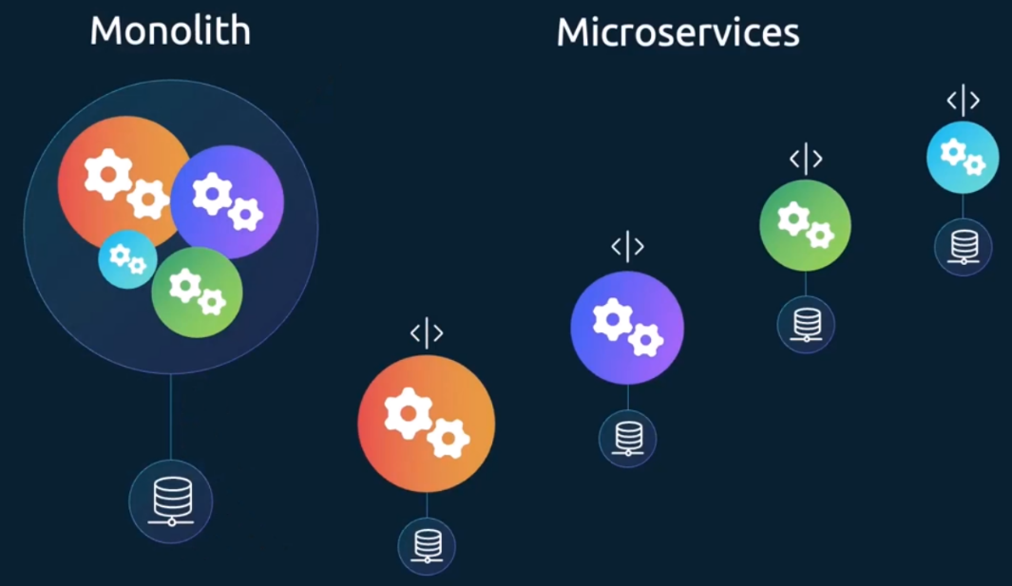
This architecture then helps us scale up and down, as well as modify each service as required, as opposed to modifying the entire application.
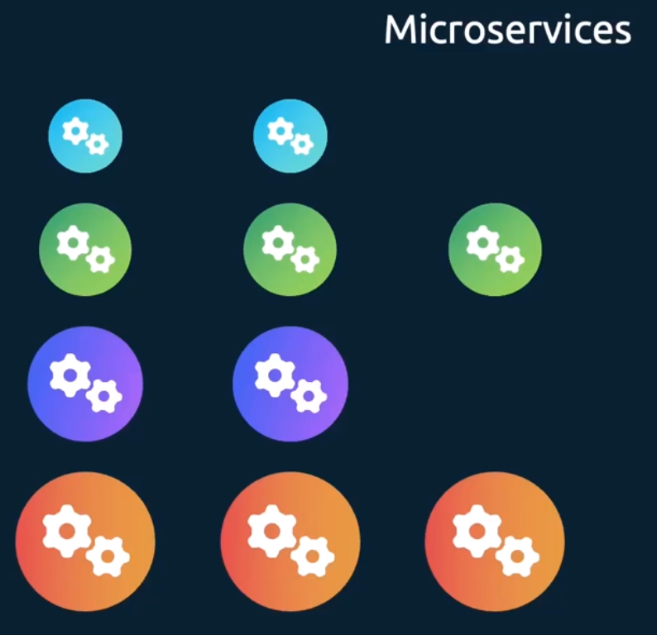
However, at times you may need two services to work together, such as a web server with the main app. You need one web server per each app instance paired together. You don't want to merge and bloat the code of the two services, as each of them target different features, and you still like them to be developed and deployed separately. You only need the two functionality to work together.
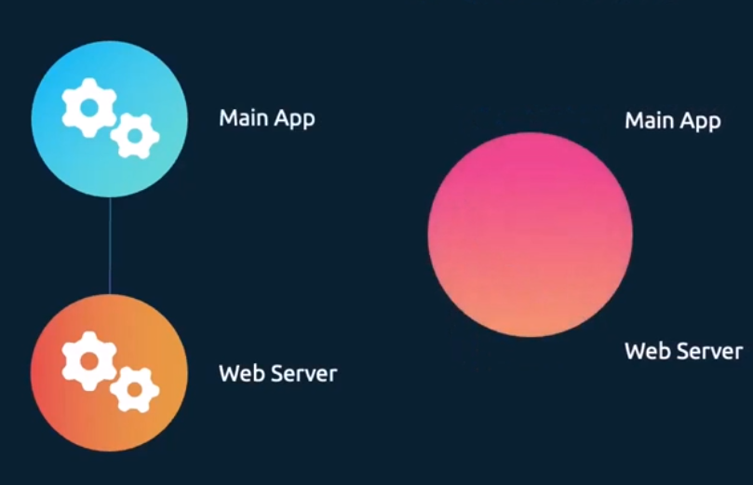
You need one web server per main app instance paired together so they can scale up and down together. And that is why you have multi-container pods that share the same lifecycle, which means they are created together and destroyed together. They share the same network space, which means they can refer to each other as localhost. And they have access to the same storage volumes. This way you do not have to establish volume sharing or services between the pods to enable communication between them.
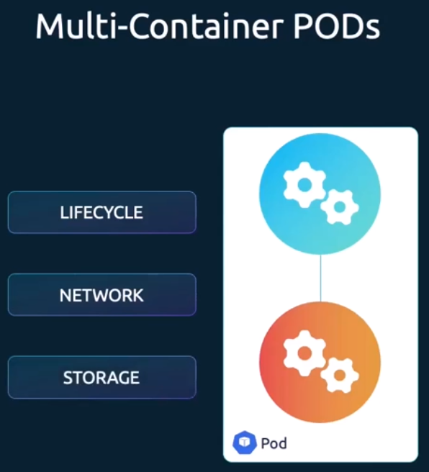
To create a multi-container pod, add the new container information to the pod definition file. Now remember the container section under the spec section in a Pod definition file is an array. And the reason it is an array is to allow multiple containers in a single pod. So now I've added another container with the name main app and the image main app. So, in this case we add a new container named a web app as container one. And then we have another container named as main app as container two.
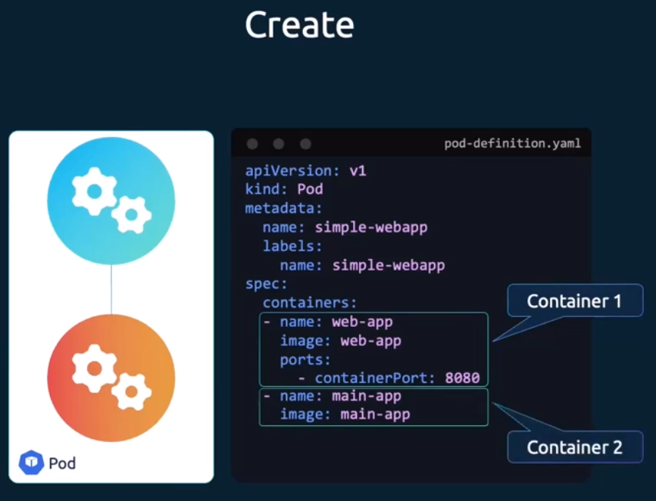

Multi container Pods Design Pattern:
There are different patterns for multi-container pods. What we just saw was the co-located containers. This is the original form of multi-container. It's as simple as two containers running in a pod. Both the containers are meant to continue to run throughout the entire pod lifecycle. These are usually used when two services are dependent on each other.
Next is the init containers or the regular init containers as it's called these days. This is used when there are initialization steps to be performed when a pod starts before the main application itself. For example, this could be an init container that waits for a database to be ready before starting the main application. The init container does its job and ends its job, and then the main application starts.
The third type is known as the sidecar container. A sidecar container is set up like an init container where the sidecar starts first, does its job, but instead of ending its run, it continues to run throughout the life cycle of the pod. The main application starts after the sidecar container starts. This is useful when you have a log shipper of sorts that needs to be run, along with the main application that needs to start before the main app starts, but continue to run as long as the main app runs and then end after the main app ends.
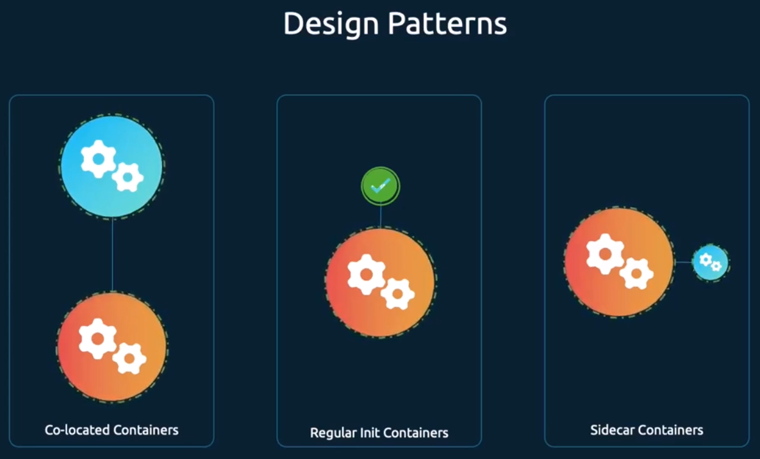
The init container is differentiated well because we know that in in terms of the init container, it starts and then stops, and then the main app runs. However, the first and the last. So, the co-located containers and the sidecar containers can be a bit confusing. So why are there two if they kind of serve the same purpose? In both of those cases, you can see that the pods are running throughout the lifecycle. So then what's the difference between the first and the last?
The main difference is that with the co-located containers, the first one, there is no ability to define which container starts first and the order of that startup. both of those containers are defined as and as elements in an in an array there is no differentiation between them, it all starts together and there is no guarantee that one would start before the other. if that's not a real requirement for your use case, you may use that option. However, the Sidecar Containers option provides the ability to specify an order of startup and then continue to run throughout the pod lifecycle. we'll see how to do that in the upcoming slides.
Let's start with the first one, here we have the pod definition file for the original uh, the co-located containers. In this case you can see that the container section is an array and it has two elements in the array two containers specified in the array. when the pod is created, both of them start. There's no particular order in which they start and they continue to run.
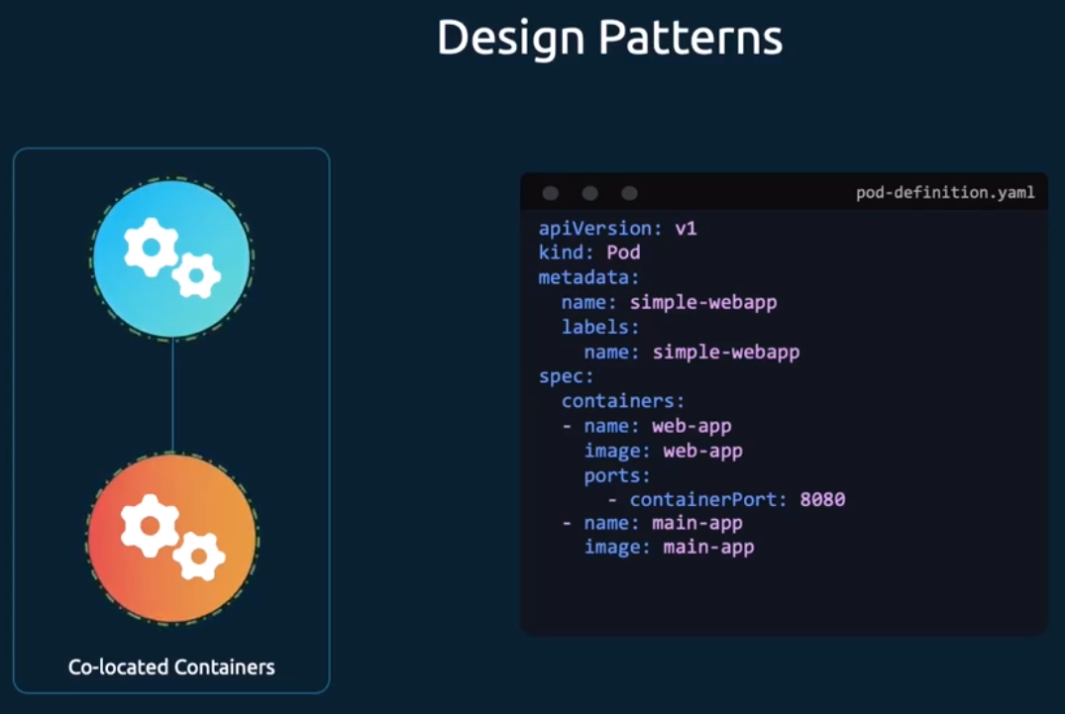
Next, we have the regular init containers. this is where instead of adding another container as the second item in the containers list, we define a separate property altogether called init containers and under that we follow the same pattern as we do for containers. under that we have the name and image and command as we do for the main container. This init container by default runs at the start and ends its run. In this case, once the wait for db to start script ends, then the main container starts. you could define multiple init containers too, so that they can be run sequentially. For example, you could have another init container defined as a second item in the list, in this case. The second item is called an API checker and it waits for another API to be started. what happens is first the checker script runs that container, runs and ends, and it ends that run and then the second container init container starts, the API checker starts and then it ends its run and then the main application starts and then it continues to run until the end of the pod lifecycle. So that's how you can define an order of startup for the init containers.
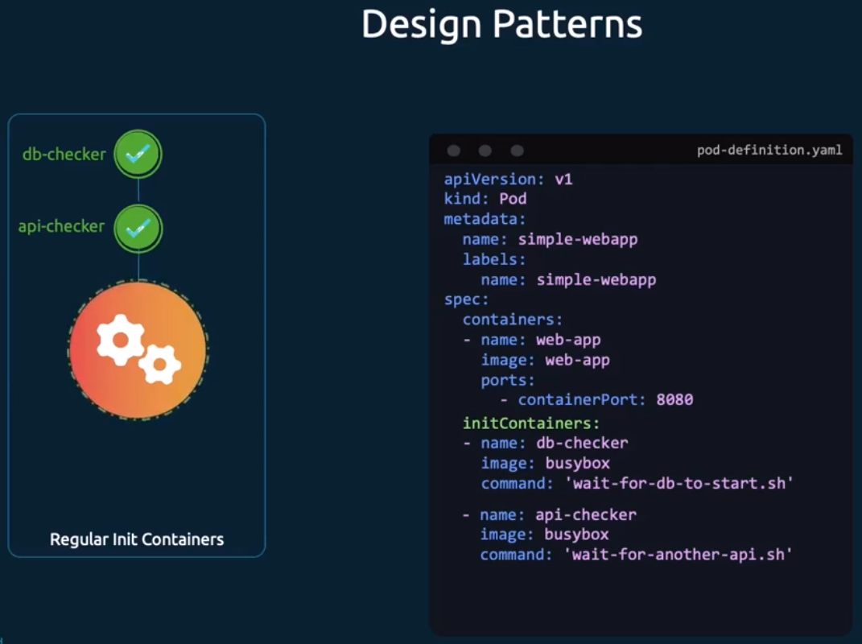
Now the third pattern is the sidecar containers. this is where we still use the init container approach. as you can see the code is still there and this ensures that the init container starts first and once they're ready the main app starts. However, the init container continues to run as it has a restart policy set to always. this will also ensure the init container is terminated after the main application stops. That way the log shipper can catch the startup and termination logs of the main container.
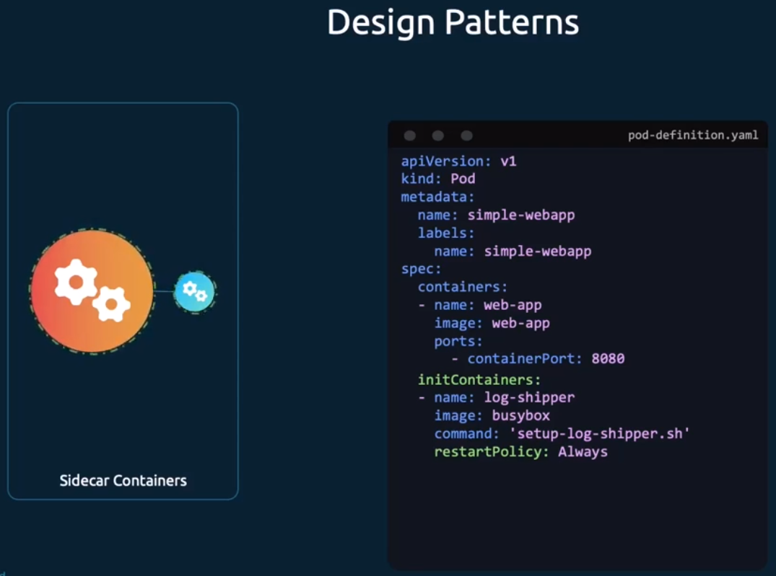

Here's a more realistic example using the elastic search and Kibana stack. this is a log collection aggregation framework and where the elastic search is itself is a component that captures the logs from different endpoints, different applications and Kibana is a visualizer that visualizes the logs, which is what which is a dashboard that users or administrators look at. in this case, what we do is along with the app, we add a sidecar called Filebeat, which comes along with Elasticsearch and that starts before the main app starts, so that it can capture the startup logs of the application, and then ends after the main app ends, so that it can capture any termination logs in case the in case the application ended due to any bugs, the termination log needs to be captured so that can be diagnosed and that is achieved using a sidecar container.
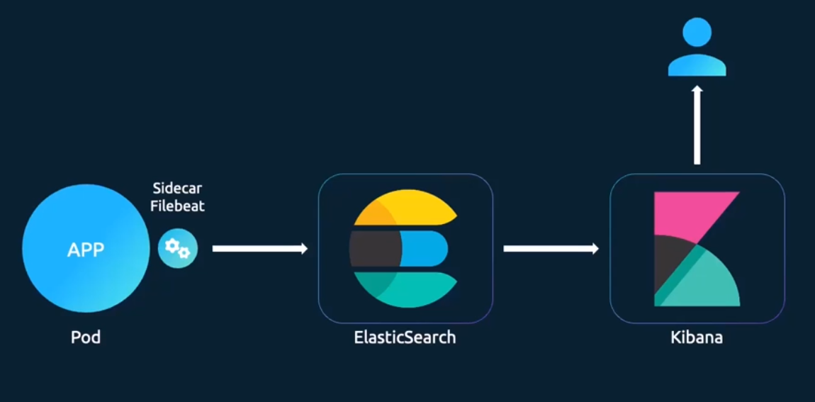

* Read the log from the specific container in the pod:
kubectl logs <pod-name> -c <container-name>
kubectl logs orange -c init-myservice
(2025 Updates) Introduction to Autoscaling:
We're going to talk about horizontal pod auto scaling or HPA vertical pod auto scaling or VPA. before we begin to look at auto scaling, let's look at what scaling means in the first place. let's forget about Kubernetes and containers for a second and go back to the plain old servers and apps hosted on physical servers.
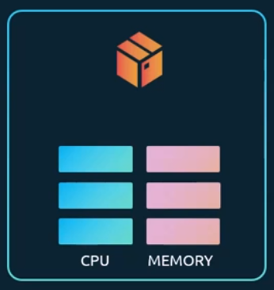
If you go back in time, millions and millions of years ago, when we used to host applications on physical servers with a predefined CPU and memory capacity. And what happens when the load increases and we run out of existing resources on the server. Now we need to scale up the server. we took down the application and added more CPU or memory resources to it and then powered it back up and that's referred to as vertical scaling. as you just saw we basically increase the size of the existing server vertically. We added more resources to our existing server by adding more CPU and memory components to it vertically and so that's vertical scaling if the application supported running in multiple instances.
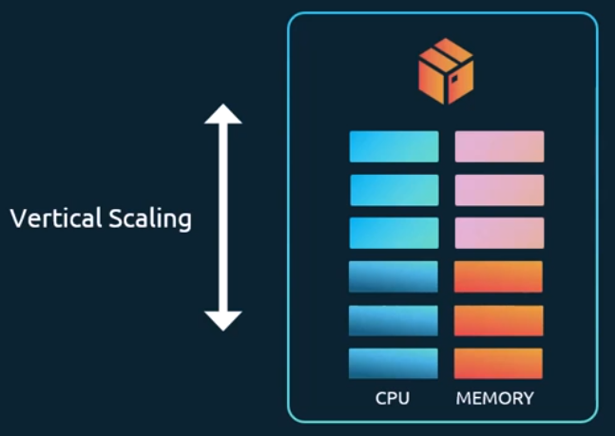
Another thing we could have done is that we could have avoided having to shut down the server. Instead, we could have added more servers to it and shared load between them. So, running more instances of the application by adding more servers is known as horizontal scaling, that's the basics of scaling.

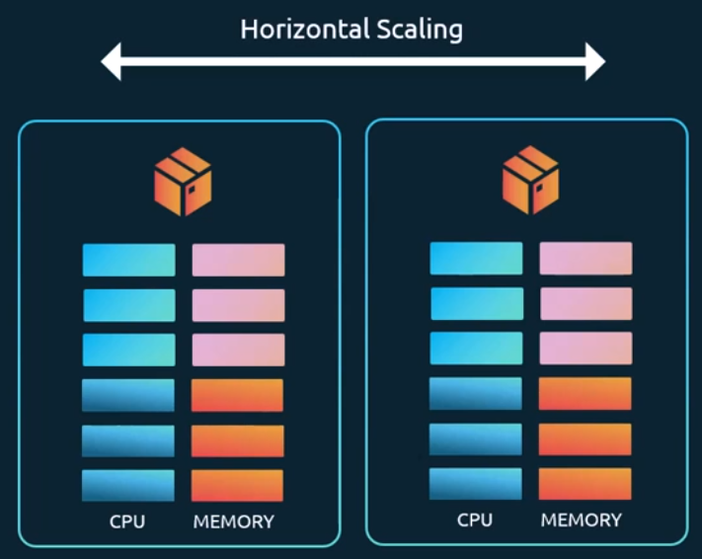
Vertical scaling refers to adding more resources to existing application, and horizontal scaling refers to adding more instances or more servers to your system.
Now let's look at how that relates to Kubernetes and the container world. When we first introduced Kubernetes, we mentioned that one of the major purposes of a container orchestrator like Kubernetes is to host applications in the form of containers and scale up and down based on demand, there are two types of scaling in Kubernetes.
What we just spoke about scaling workloads. you can scale the workloads by adding or removing containers or pods onto the cluster, another approach to scaling is scaling the underlying cluster itself, that's adding or removing more servers or infrastructure to your cluster.
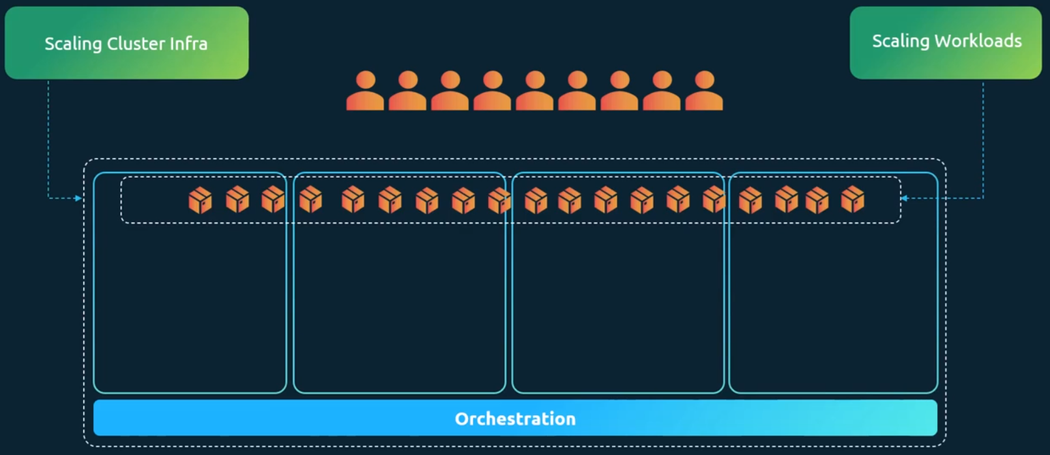
There's scaling workloads and scaling the cluster infra, let's look at what this mean. there are two ways of scaling these individually. there's horizontal and vertical scaling. when it comes to the cluster horizontal scaling refers to adding more nodes to the cluster. Vertical scaling would mean increasing the resources on existing nodes in the cluster.
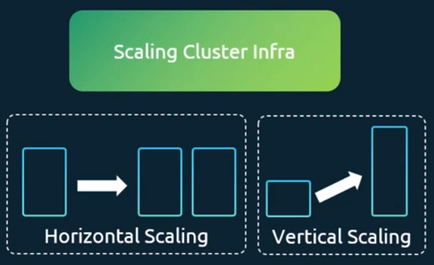
When it comes to scaling workloads, horizontal scaling would mean creating more pods and vertical scaling would mean increasing the resources allocated to existing pods.
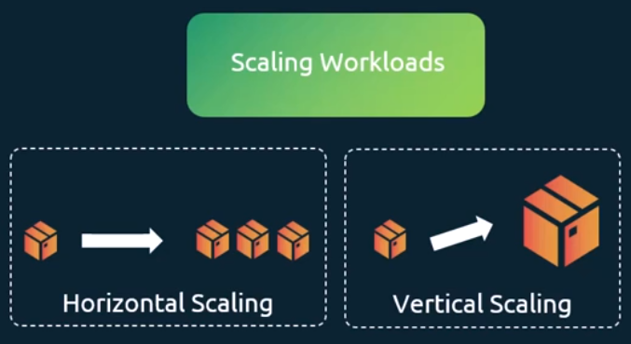
There are two ways of scaling, the manual way and the automated way.
The manual approach of horizontally scaling cluster infra would be to manually provision new nodes and then use the kubeadm join command to add new nodes to the cluster.
When it comes to vertical scaling, I don't think that's a common approach used for Kubernetes, because it would result in having to take down the server and applications running on them, and then add more resources to the servers and bring it back up, which is not something that we would want to do. So since most of the infra these days are virtual machines, you could easily provision a server with higher resources, add it to the cluster and remove the older server, so I don't think vertical scaling is that common of an approach.
Now when it comes to horizontal scaling Rescaling workloads. The manual approach would be to run the kubectl scale command on the workload, to scale up or down the number of pods.
To vertically scale resources associated to a pod, you would usually run the kubectl edit command to go in to that deployment or stateful set or replica set, and change the resource limits and requests associated with the pods.
let's look at the automated approach. for horizontally scaling the infra we have what is known as the Kubernetes cluster autoscaler. For horizontally scaling the workloads we have what is known as the horizontal pod autoscaler or HPA. And for vertically scaling workloads we have the vertical Pod autoscaler.
(2025 Updates) Horizontal Pod Autoscaler (HPA):
Let's start by looking at how I would manually scale a workload horizontally. I'm a Kubernetes administrator, and I'm sitting on my machine looking at a cluster and I'm tasked to make sure that there is always sufficient workload to support demand for this application. From a deployment configuration perspective, I see this pod requests 250 milli CPU and has a limit of 500 milli cores of CPU. This means that 500 Milli cores is the max the CPU it gets, after which it doesn't get any more and the capacity that a single pod can handle is 500 milli cores of CPU.
I would run the kubectl top pod command and monitor the resource consumption of the pod. If I had to do it manually. Now remember that you must have the metrics server running on the cluster to be able to monitor the resource usage like this.
Now, when it reaches the threshold of 450 milli cores or whatever it is that I have defined as the threshold or close to that. I would run the kubectl scale command to scale the deployment to add additional pods, that's the manual way to scale a workload. The problems with this approach are that I have to sit in front of my computer and continuously monitor resource usage, I need to manually run commands to scale up and down and if there's a sudden traffic spike and I want a break or something, I may not be able to react fast enough to support the spike in the application or in the traffic. So, to solve this, we use the Horizontal Pod autoscaler.
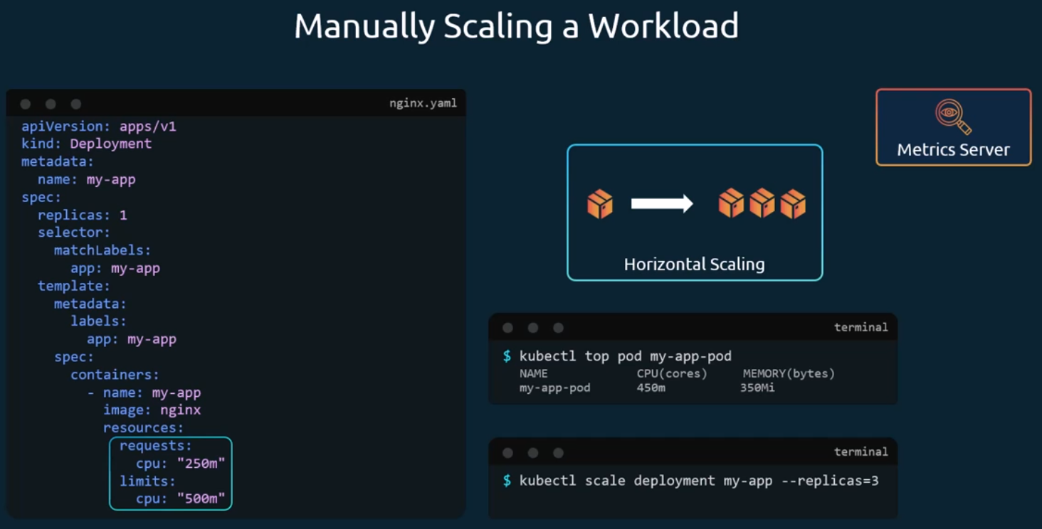
The horizontal Pod autoscaler continuously monitors the metrics as we did manually use the top command. It then automatically increases or decreases the number of pods in a deployment Stateful set or replica set based on the CPU, memory, or custom metrics and if the CPU, memory, or memory usage goes too high, HPA creates more paths to handle that, and if it drops, it removes the extra pods to save resources and thus balances the thresholds and note that it can also track multiple different types of metrics, which we will refer to in a few minutes.
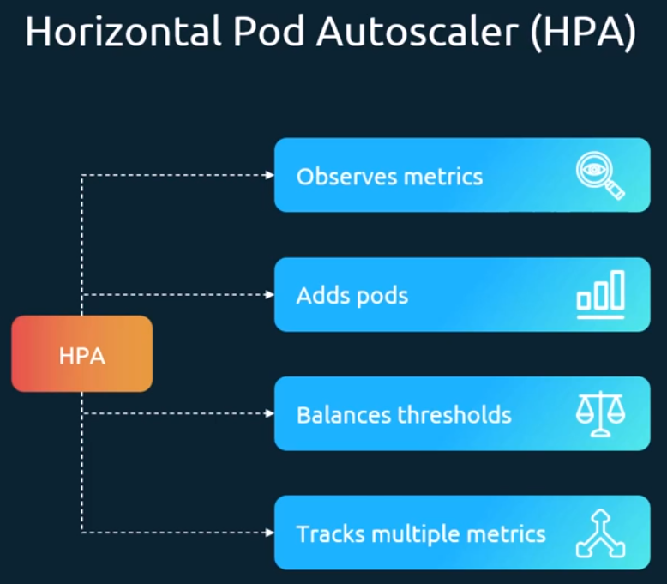
Let's see this in action. For the given nginx deployment, we can configure a horizontal pod autoscaler by running the kubectl autoscale command, targeting the deployment my-app, and specifying a CPU threshold of 50% with a minimum of one and maximum of ten pods. when this command is run, Kubernetes creates a horizontal pod autoscaler for this deployment that first reads the limits configured on the pod, and then learns that it's set to 500 milli core. It then continuously pulls the metric server to monitor the usage, and when the usage goes beyond 50%, it modifies the number of replicas to scale up or down, depending on the usage. to view the status of the created HPA, run the kubectl get HPA command and it lists the current HPA. The targets column shows the current CPU usage versus the threshold we have set, and the minimum and maximum and the current count of replicas. it would never go beyond the maximum that we have specified when scaling up, and it would not go beyond the minimum that we specified when scaling down. And when you no longer need the HPA, you can delete it using the kubectl delete HPA command.
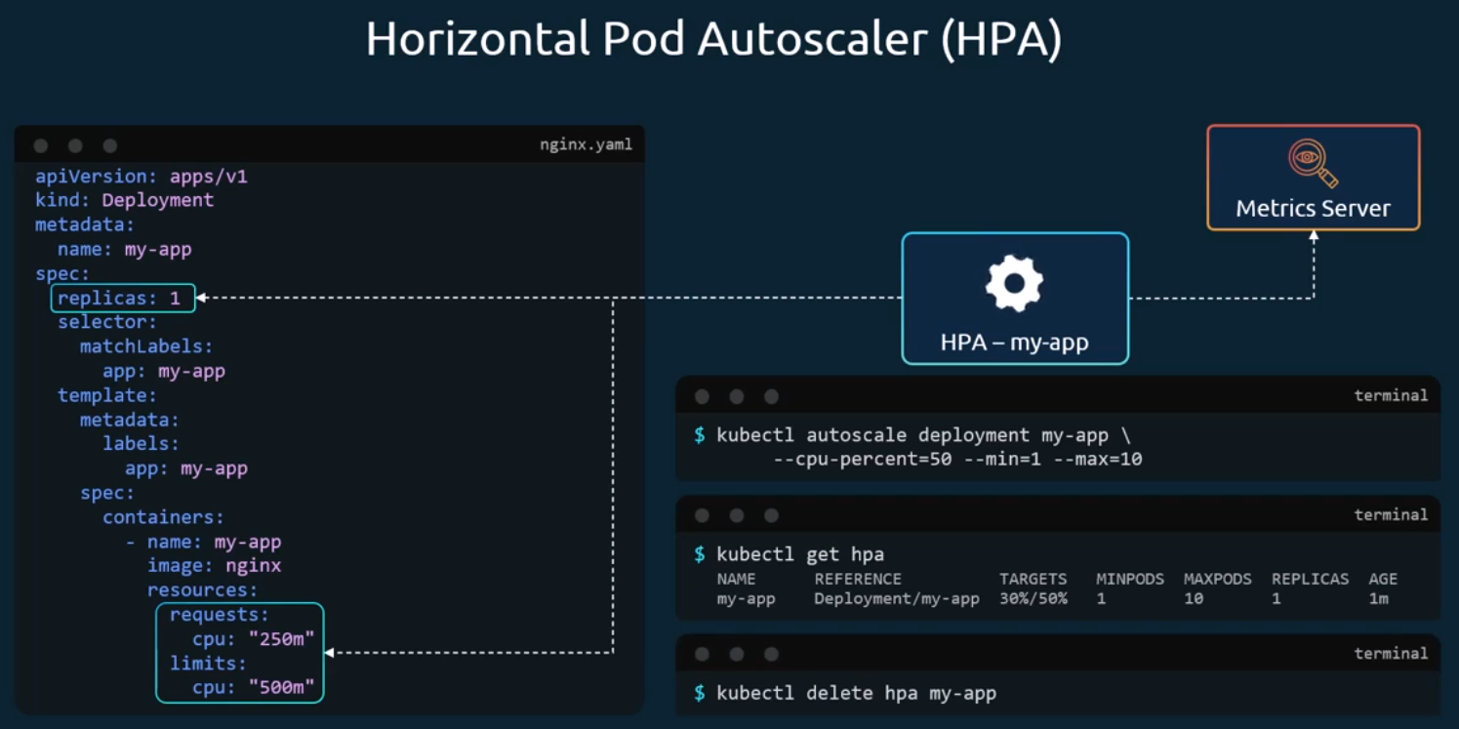
There's also a declarative approach. create an HPA definition file with the API version set to auto scaling v2 kind is set to horizontal pod autoscaler. The name is set to Myapp HPA and then we have the scale target ref. This is the target resource we want the HPA to monitor. That's the deployment named Myapp. We also have the min and max replicas defined. And then we have configured the metrics and resources to monitor in this case the resource being CPU and target utilization, uh being 50%.
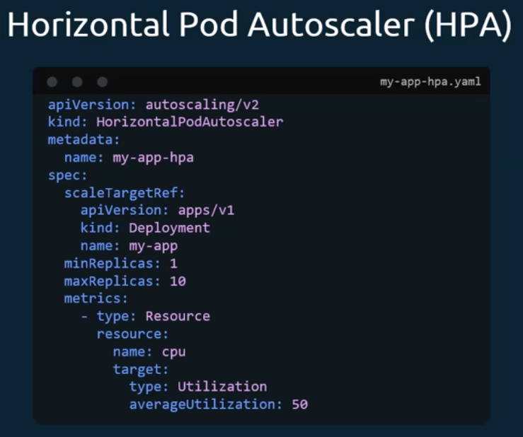
Now note that HPA comes built in with Kubernetes since version 1.23, so there is no separate installation procedures required. Note that it relies on metric server, so that is a prerequisite. talking about metric server we spoke about the metric server that HPA depends on to get current resource utilization numbers. Now what we have been referring to is the internal metric server. But there are also other sources that we can refer to, such as a custom metrics adapter that can retrieve information from other internal sources, like a workload deployed in a cluster. However, these are still internal sources. We can also refer to external sources, such as tools or other instances that are outside of the Kubernetes cluster, such as a Datadog. Or Dynatrace instance using an external adapter.
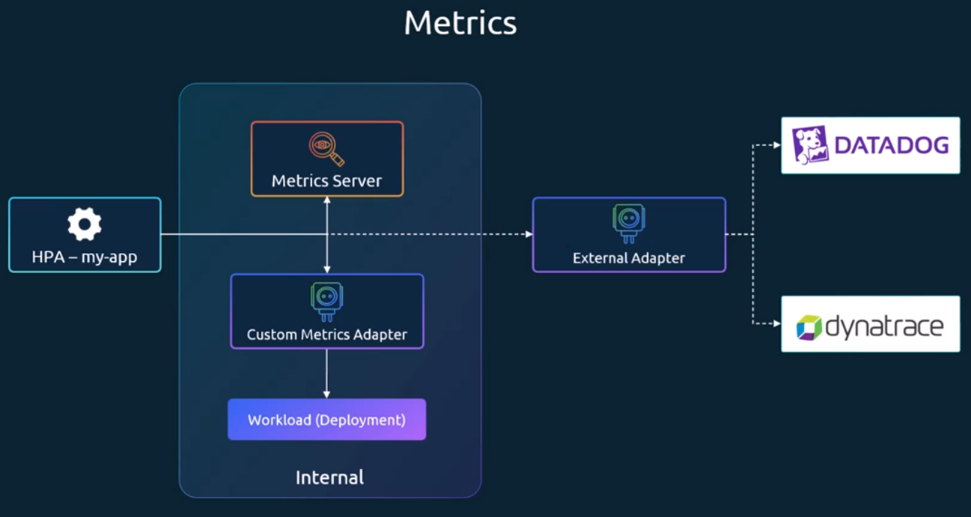
(2025 Updates) In-Place Resize of Pods:
Let us now look at in-place resizing of pods. before we talk about Vertical Pod autoscaler, I thought it would be a good idea to talk about in-place resize of pod resources. what does that mean? Now as of this recording, which is Kubernetes version 1.32 has released, if you change resource requirements of a pod in a deployment, the default behavior is to delete the existing pod and then spin up a new pod with the new changes. any resource, any changes to the resource definitions on pod does not happen in place, which means the pod needs to be killed and the new pod with the new resource definitions need to be created, that's the default behavior.
Now we know that this can be disruptive, especially for stateful workloads. there is an improvement that is being worked upon called as in-place update of Pod resources. This is a feature that is currently in alpha as of Kubernetes release 1.27, and is not enabled by default, and when it goes to the beta or stable stage in the future, it will become enabled by default. But as of this recording it is not. it is still available with the features that are part of the Kubernetes cluster. You just have to enable it, to enable this feature, you must set the feature flag called in-place pod vertical scaling to true and once this is enabled, the Pod definition supports a set of resize policy parameters, which we will look at next. the new resize policy options allow you to specify a restart policy for each resource.
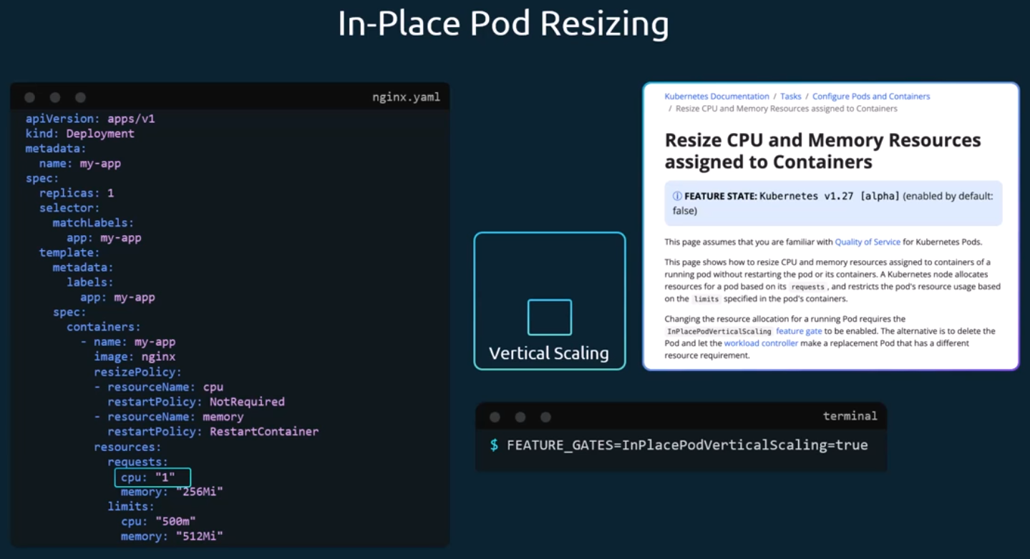
In this example, we have defined that a change in CPU resource will not require the pod to be restarted, and a change in memory will require a restart of the pod and the next we make a change to a resource such as updating the CPU to one, and you can see that the pod does not need to be killed. Instead, it can simply be updated with the new resources and so it can just increase in size. So that explains how we can resize a CPU or memory resource assigned to a container without really restarting it.
Some of the limitations of in place resizing of pods to keep in mind is that this only works for CPU and memory resources.
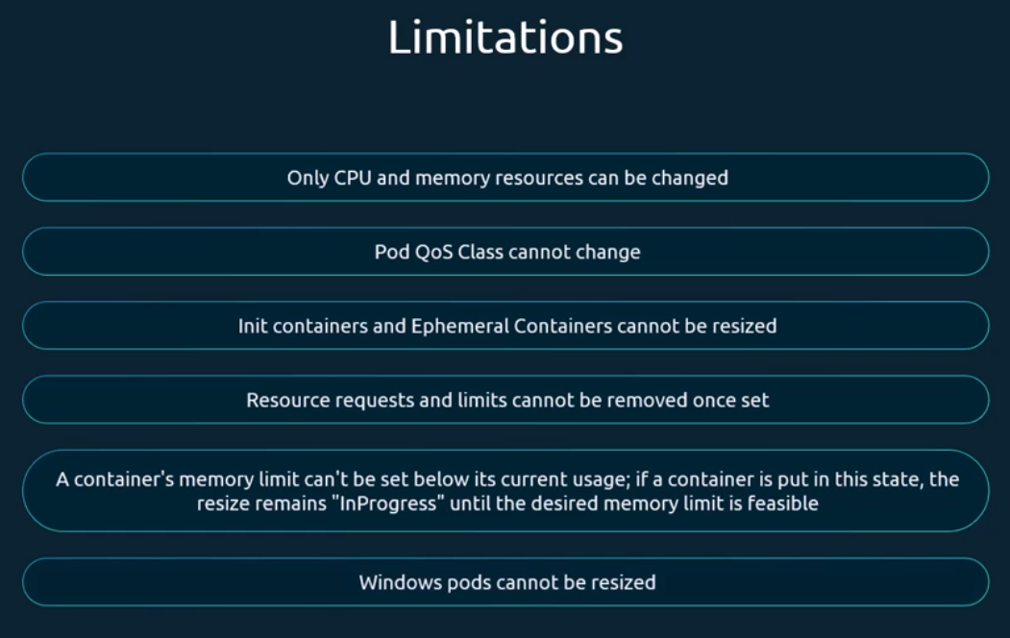

(2025 Updates) Vertical Pod Autoscaling (VPA):
Let's now look at vertical pod autoscaler in Kubernetes. let's start by looking at how I would manually scale a workload vertically. Say I am a Kubernetes administrator and I'm sitting on my machine looking at a cluster. I'm tasked to make sure that there is always sufficient workload to support demand for this application and from the deployment configuration, I see that this pod requests 250 milli cores of CPU and has a limit of 500 milli cores of CPU and this means that 500 milli cores is the max capacity it gets. So, as I did before, I would run the kubectl top pod command and monitor the resource consumption of the pod and remember that you must have the metrics server running on the cluster to be able to monitor as the same as before and when it reaches a specific threshold, what I'm going to do to scale the pod vertically is run the kubectl edit deployment command. I will run the edit deployment command and I would change the resource requests and limits assigned to the deployment under the pod template, under the container section, and then save it and what would happen is it would then kill that pod and create a new pod.
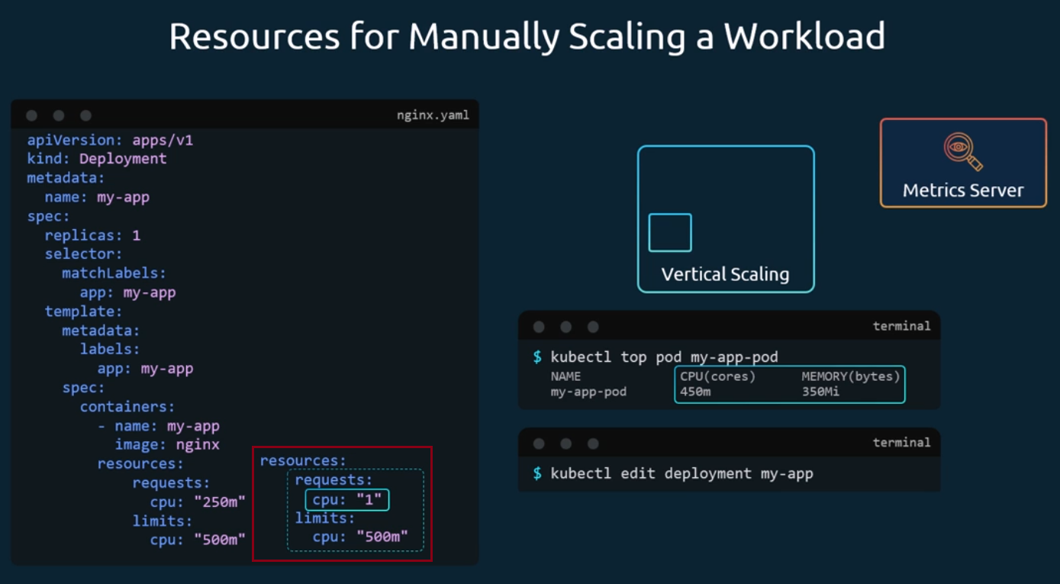
That's basically how I would do it manually and we don't want to do it manually, we have the vertical pod autoscaler for that. similar to the horizontal Pod autoscaler, the vertical Pod autoscaler continuously monitors the metrics and then it automatically increases or decreases the resources assigned to the pods in a deployment and thus balances the workload.
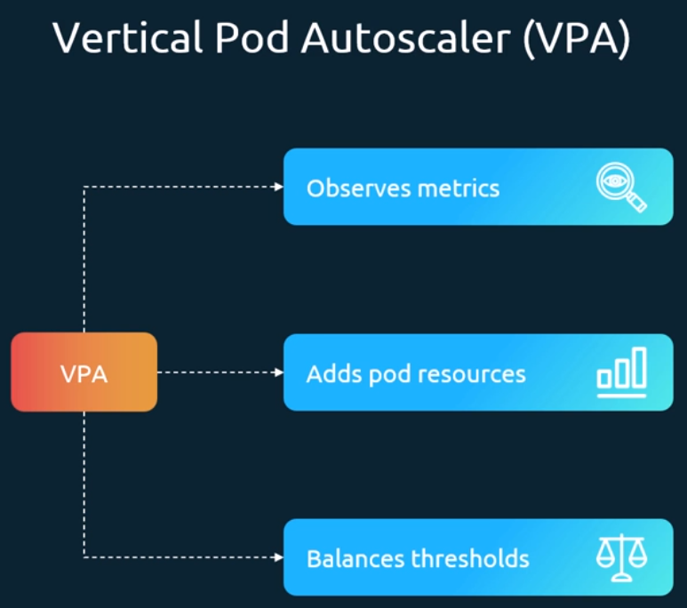
Let's look at it in a bit more detail. unlike the horizontal Pod autoscaler, the vertical pod autoscaler does not come built in, as such, we must deploy it. we first apply the Vertical Pod Autoscaler definition file available in the GitHub repo and then when we run the kubectl get pods command in the kube system namespace and search for VPA. We will be able to see that there are multiple components deployed. there is the admission controller recommender and the updater service which should be running.
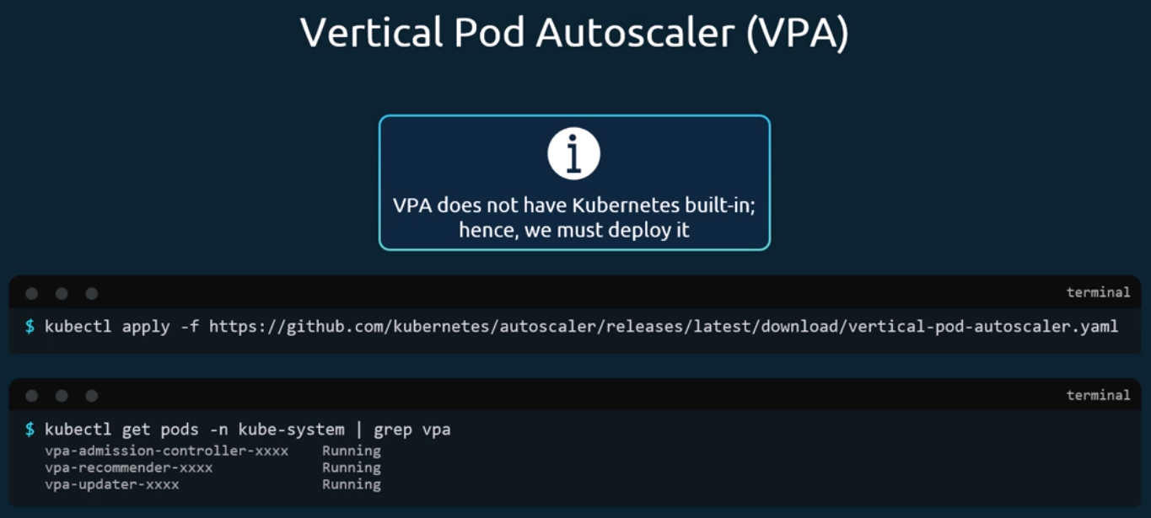
Let's look at what those are. the VPA deployment consists of multiple components, there are the VPA admission controller, the updater and the recommender. the recommender is responsible for continuously monitoring resource usage from the Kubernetes metrics API and collects historical and live usage data for pods, and then provides recommendations on optimal CPU and memory values and the recommender, itself does not modify the pod directly or it only suggests changes. The updater detects pods that are running with suboptimal resources and evicts them when an update is needed, so it gets the information from the recommender and monitors the pod, and if a pod needs to be updated, it evicts them, that means it just terminates the pod and the admission controller intervenes the pod creation process and uses the recommendations from the recommender again, to then mutate the pod spec to apply the recommended CPU and memory values at startup and this ensures that the newly created pods start with the correct resource requests. Basically, the VPA recommender collects information. The updater monitors or gets the information from the recommender compares that to the actual pod and if the pod is beyond the threshold, it kills the pod and the whether it kills or not, that depends on the policy that we will talk about in a bit. But ideally it would kill the pod, and then the admission controller intervenes, because when a pod is killed, it's automatically the deployment will automatically recreate the pod and when it does that, the admission controller intervenes and updates the resources so that the pod is now comes up with the new size.
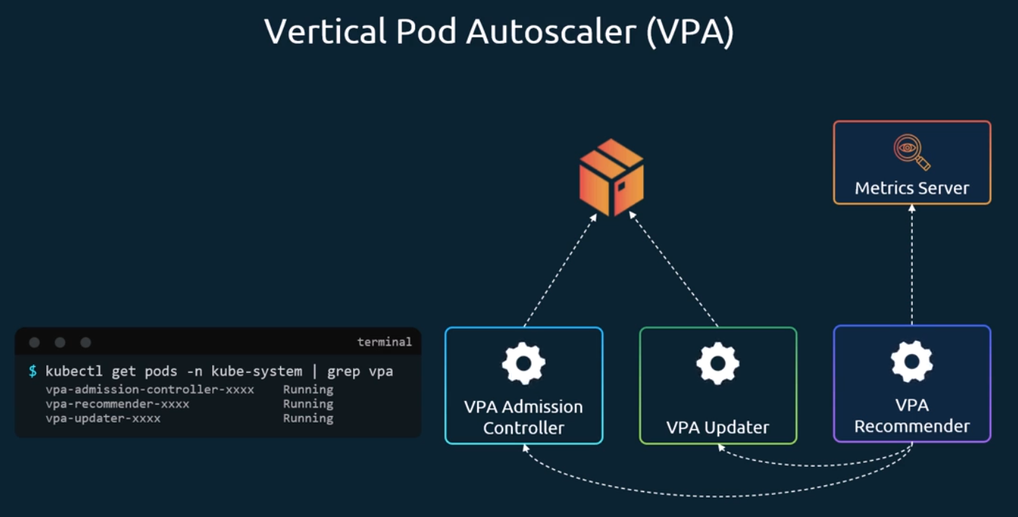
Let's look at how to create the VPA service using a definition file. note that there is no imperative command to create a VPN because it's not a built-in component like the HPA. here we have the API version which is auto scaling.io v1. The kind is vertical pod autoscaler. The name is my-app VPA. The target to monitor is the my-app deployment. The container policies define what is monitored. In this case, the CPU minimum allowed and max allowed are configured and finally we have the update policy mode. there are four modes that VPA operates in.
The off mode, which only recommends changes but does not do anything. in this case it's only the recommender working. The updater and the admission controllers are not working.
The initial mode that only changes pods on creation, not later. in the initial mode, the recommender recommends a change and when the deployment is scaled for some other reason and the new parts come up. The admission controller intervenes and changes the pod's resource definitions. The updater in this case does not work to kill or the take down the pod in case of the recreate mode. That's where the updater component jumps in and evicts an existing pod when its resource consumption goes beyond a range specified.
The auto mode that updates existing pods to the recommended numbers. Again, for now, this behavior is similar to recreate. So as of now, the auto mode works exactly as recreate mode. But when the support for the in-place update of resources is available, the one that we spoke about in the previous video, then that mode would be preferred over recreate. that auto mode is really built for the future. when the in-place update of resources is available in stable version of Kubernetes. That would be the default behavior, but as of now, the auto mode works exactly like recreate, if a pod goes beyond a range, it is killed.
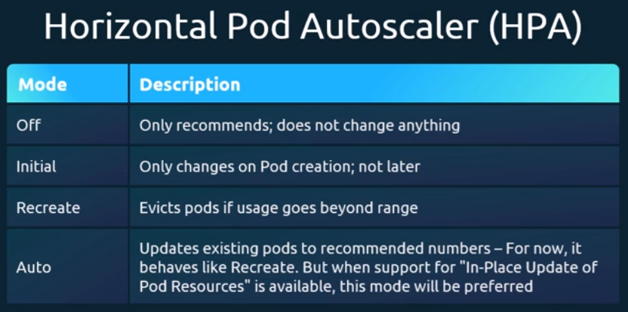
VPA will monitor resource usage and suggest adjustments so we can check the recommendations, with the command kubectl describe VPA followed by the name of the VPA and here you can see that the recommendation, VPA suggests increasing CPU to 1.5.
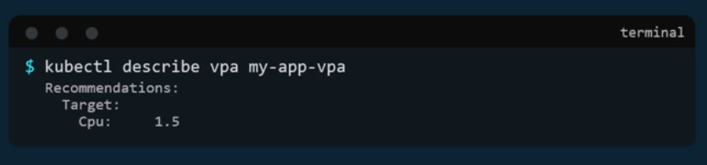
We spoke about horizontal and vertical pod autoscaler, but you must be wondering when to use which. let's kind of compare the two.
First let's look at the scaling method. VPA as we know works by increasing CPU and memory for existing pods or by just recreating those pods with the new resources, whereas HPA adds or removes pods based on demand. This means that the VPA optimizes individual pod performance um, while HPA focuses on distributing the load across multiple instances.
Pod behavior, VPA restarts pods to apply the new resource values. This means downtime is involved when scaling up vertically. In contrast, HPA keeps existing pods running and simply spins up new ones, ensuring continuous availability.
Handling traffic spikes, HPA is clearly the winner here. It instantly adds more pods when demand increases, making it the preferred choice for applications that require rapid scaling and VPI. On the other hand, cannot handle sudden spikes efficiently because it requires restarting pods, typically, which introduces delays.
Cost optimization perspective, both have advantages. VPA prevents overprovisioning by adjusting CPU and memory allocation to match actual usage, and HP, on the other hand, avoids unnecessary idle pods, ensuring that resources are used efficiently without keeping excess instances running.
When should you use which (Best for)? So VPA is best suited for stateful workloads and CPU or memory heavy applications such as databases JVM based applications. AI ML workloads that require fine-tuned resources. let's say some applications require like heavy CPU in the initial startup, but then later does not require that much CPU. What you could do is that's where VPA comes in. you could start the instance with a lot of CPU and once that initialization process is over, I mean when it needs to reduce the CPU memory usage allocated to it, then that's where VPA comes into picture. The HPA is ideal for web applications, microservices and um, stateless services such as web servers, message queues, and API based applications where quick scaling is needed to handle fluctuating traffic. in summary, VPA is about optimizing resource allocation for individual pods, while HPA is about scaling the number of pods dynamically based on demand. So, choosing the right autoscaler depends on the workload type and how you need to scale your application.
